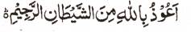

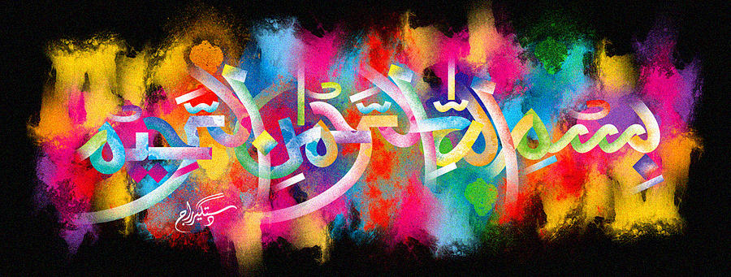
http://dr-umar-azam-islamicmiracles.weebly.com
Please see my Site, especially the RESEARCH section and sign my Guest Book with your unique comments.

THE NAME OF MUHAMMAD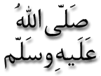 ON A POMEGRANATE
The Exclusive Islamic Miracle Photographs of Dr Umar Elahi Azam
^{SATURDAY} 2 JANUARY 2016
Manchester, UK
Although these photographs belong to Dr Umar Azam, readers have permission to use any/all of the photographs as long as the source is acknowledged. Miracle Photographs, for example, have been shared on Twitter in the recent past.

The name of the Prophet needs to be read downwards in all of the photographs below.
