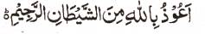

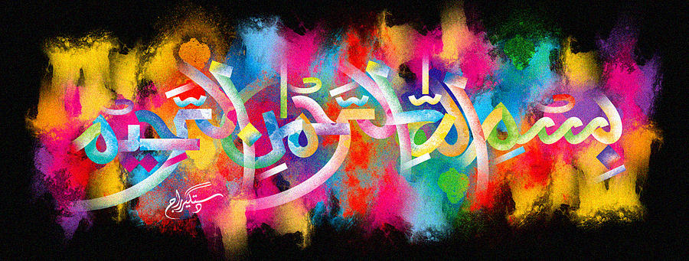
http://dr-umar-azam-islamicmiracles.weebly.com
Please see my Site, especially the RESEARCH section and sign my Guest Book with your unique comments.

The Name of Allah on a Taro Vegetable
The Exclusive Islamic Miracle Photographs of Dr Umar Elahi Azam
Wednesday 13 January 2016
Manchester, UK
Although these photographs belong to Dr Umar Azam, readers have permission to use any/all of the photographs as long as the source is acknowledged. Miracle Photographs, for example, have been shared on Twitter in the recent past.

Introduction
This vegetable is called Arbi or Arvi in Punjabi and Taro or Eddoes in English.
The Name of Allah is at the left-hand side on the bottom row.
