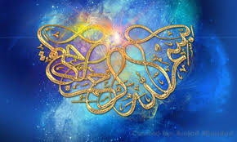
The NAME OF ALLAH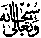
LOTS AND LOTS OF TIMES ON THE SLICES OF A BIG SATSUMA
VOL. 2
The Exclusive Islamic Miracle Photographs of Dr Umar Elahi Azam
Friday 28th August 2015
Manchester, UK

Introduction
The Name of Allah appeared juust once on t5he surface of a giant Satsuma but a multitude of times on its segments! This miracle was discovered and photographed between c. 6:00 – 6;30 am
