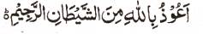

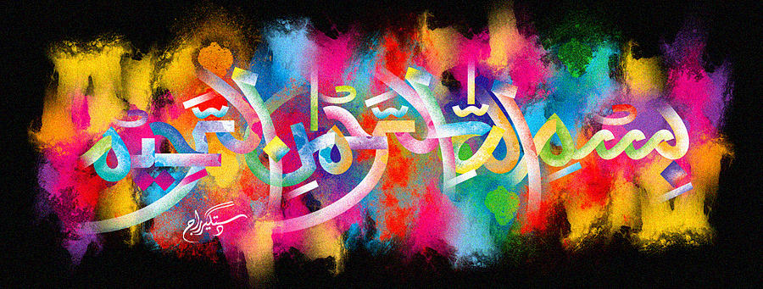
http://dr-umar-azam-islamicmiracles.weebly.com
Please see my Site, especially the RESEARCH section and sign my Guest Book with your unique comments.

A HUGE MARKING OF THE NAME OF ALLAH ON A CANTALOUPE MELON
The Exclusive Islamic Miracle Photographs of Dr Umar Elahi Azam
^{FRIDAY} 1ST JANUARY 2016
Manchester, UK

Introduction
This marking was larger than 50% of one side of the melon!
