The Method of Producing

Research Papers on ‘The

Islamic Miracle Photographs of Dr Umar Elahi Azam’

http://dr-umar-azam-
islamicmiracles.weebly.com

Manchester, UK

Thursday27 August 2015
Introduction

I separate the checking of the fruit or other

produce from the process of photography; for example, I separated five bananas from their bunch and looked at each one individually. When a holy marking of the Name of Allah SWT or that of Muhammad SAW was found, I took two or three photographs of each marking, changing the angle here and there. I also moved the fruit further away from my smartphone camera lens, or closer, depending on whether the image is burred or sharp. Having taken the photograph of one marking,
I turned the smartphone back to standby mode, examined the next fruit and repeated the process. If plenty of markings were found, I made a table and jotted down the
fruit number and what particular markings

were found, abbreviating the Name of Allah SWT to ‘A’ and the name of Muhammad SAW to ‘M’; if both were together on the same fruit I recorded the markings as ‘A-M’:

For example [this is a hypothetical example, not actual findings]:

Banana No. |  |  |  | Markinging |  |  |  |  | g
 | 1. |  |  | A
2. |  |  |  | M
3. |  |  |  | A, A, M
4. |  |  |  | A-M |  | , UAr
5. |  |  |  | M, M

So, in the table above, M, M would mean that

2 markings of the name of Muhammad SAW were found on the same banana. UAr means: ‘Unidentified Arabic’. Then I emailed the photographs in batches of 9 from my photos album on my Sony Xperia M2
Smartphone to my Gmail address [if more than 9 photographs are sent a message informs me that the amount of kb has been exceeded and that one or more of the photographs will not be sent. In the case of my Paper of 18/8/15, I had 36 photos to send, so I sent 4 batches of 9 to my email account.
In the ‘subject’ line of the email, I entered

‘Bananas I’ [i.e. the first batch of 9] and in the main body of the email, I just typed: ‘Here.’ Then, when I wanted to upload the photographs onto my Islamic Miracles
Website; http://dr-umar-azam-

islamicmiracles.weebly.com , I opened my Gmail account and downloaded the first batch of 9 onto the ‘Pictures’ folder of the computer memory storage. Then I logged onto the control panel of my Weebly Website and uploaded the photos from that ‘Pictures’
folder to each ‘Image’ icon in my Website Editor. So that I didn’t get confused after I had prepared one Paper, I deleted the photographs from the ‘Pictures’ folder before uploading the next set. The following sequence is the action to take to delete the photographs stored in that folder:

Organise > Select all > Organise> Delete> |  |  | Pop-
up confirmation: Are you sure you want to delete all selected? | > Yes

For multiple Papers, I have the first MS

Word document that acts as a template or default draft for all subsequent Papers for that evening. I can change the fonts, colours, sizes of the fonts to offer variety in the format of the Papers. I copy and paste the title, author, date and introduction, as well as the colour separator lines, onto a new MS Word document and delete the default version.
After I have finished this second paper, it will serve as the default one until it is deleted when I begin the third Paper and its new introduction and photographs… and so on for the Papers to be produced that evening. I then convert the MS Word file to a PDF using an online conversion Site such as www.go4convert.com [it is excellent because
there is no limit to the size of the file; this I

have found invaluable because photographs take up a great deal of kilo bytes]. I store at least one MS Word file in my email account or Website because the PDF can’t be edited and so serve as the default: it has to be an MS Word file. After the PDF is available, it is this file that I upload onto my Website via the Site Editor ‘Files’ icon. I copy and paste, for example, [Miracle Photographs Research File] MRF No 101 for the next file – MRF No 102- but just change one digit – the ‘1’ into a ‘2’ to save myself having to type the whole title out again. But I find that I have to reduce the size of the font and fill in the colour every single time for each new Paper because size and
colour options are not default – the default

settings are the Site Editor settings.

Below are examples of some of my rough drafts of research Papers.

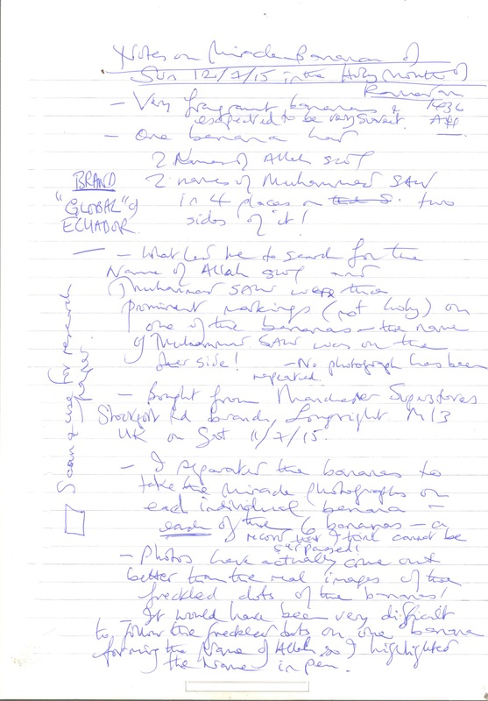
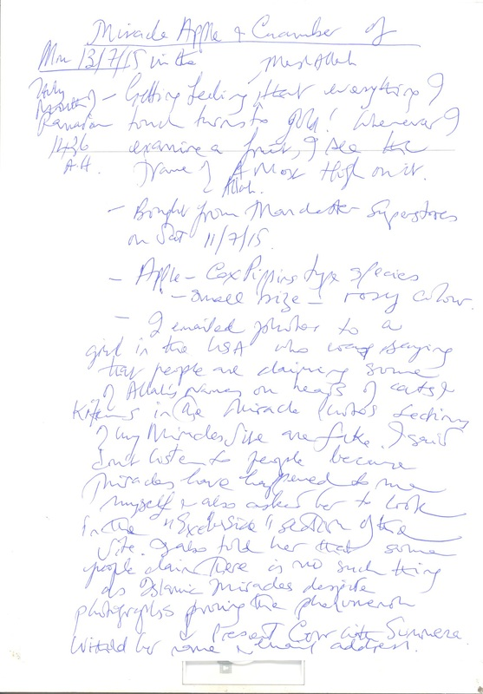
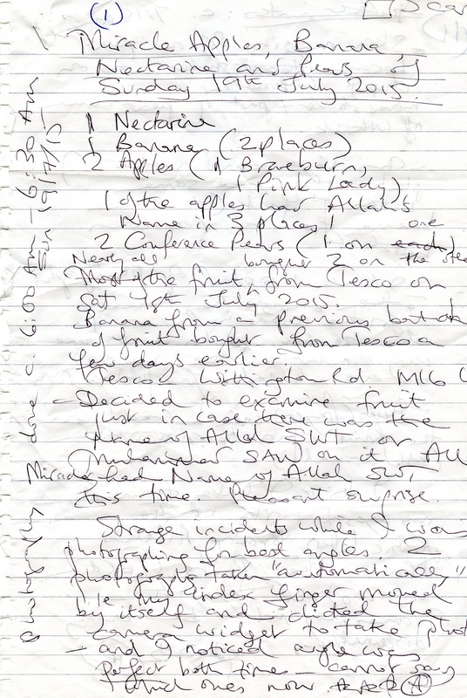
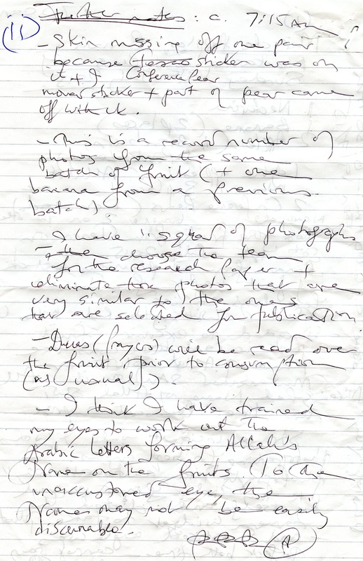
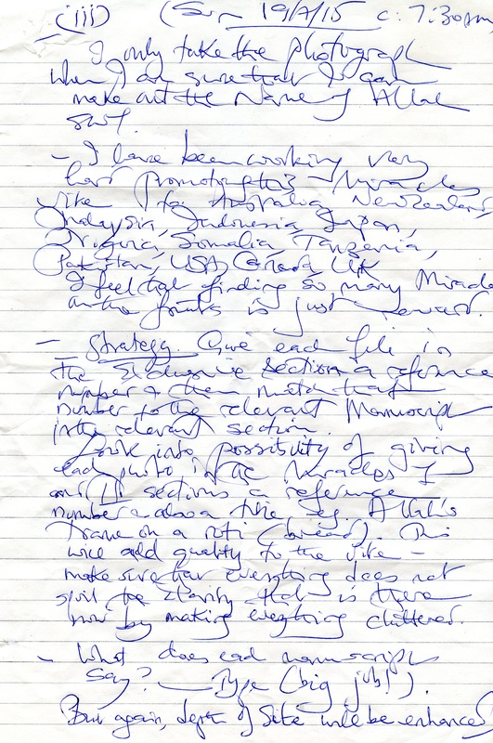
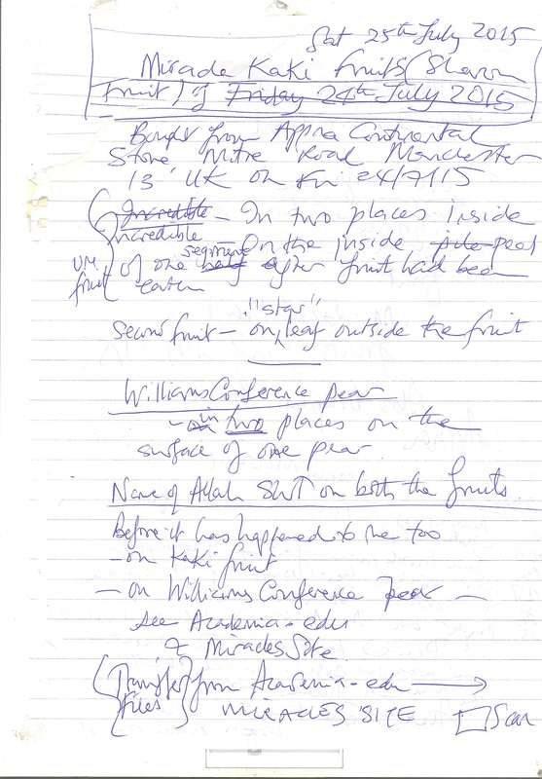
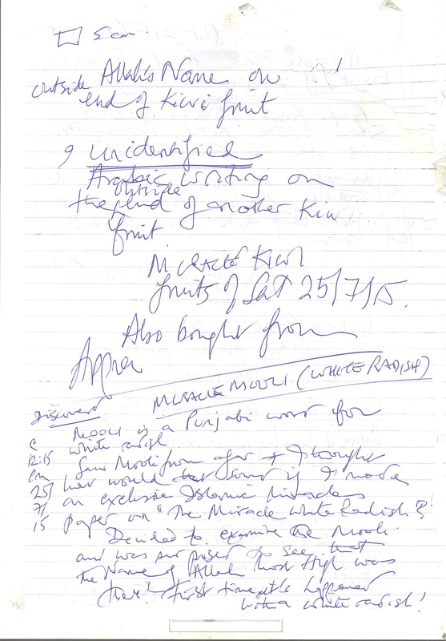
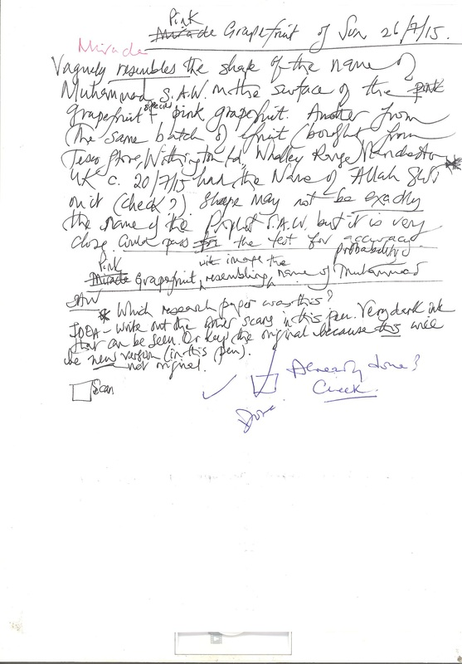
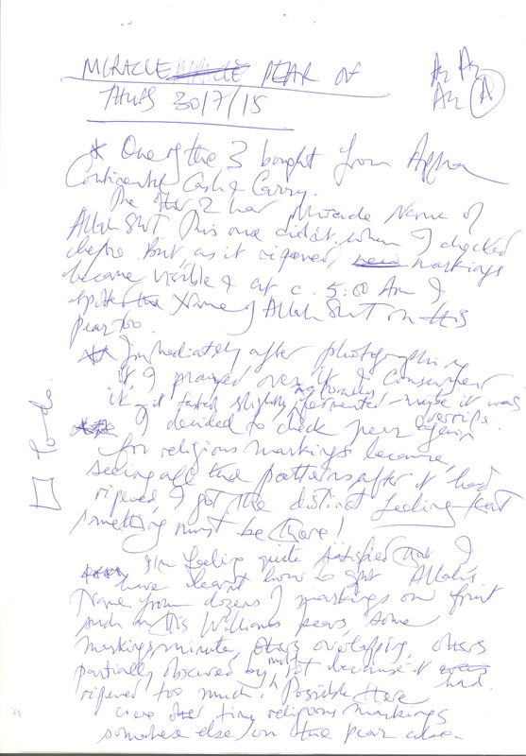
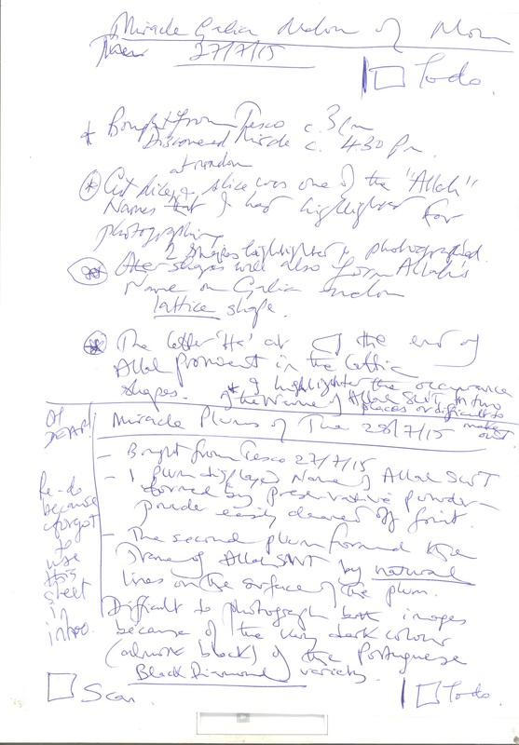
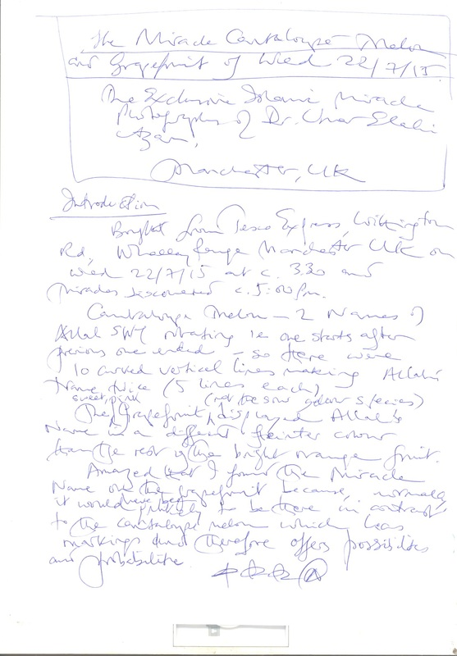
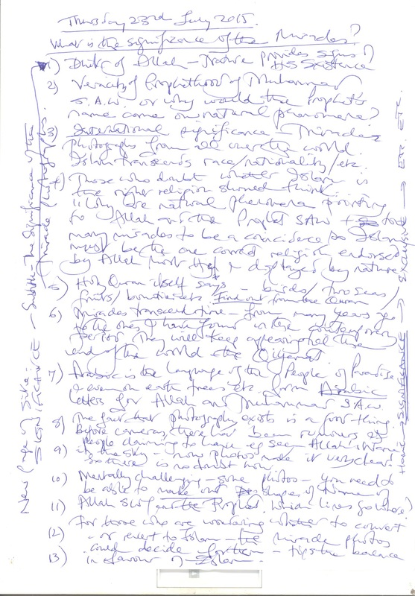
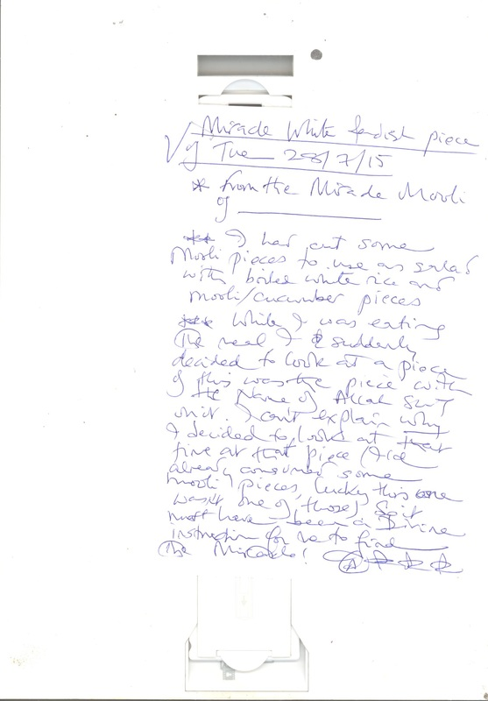
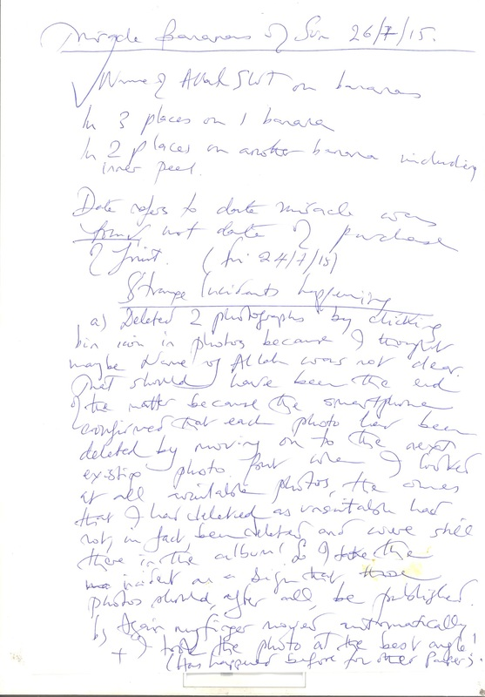
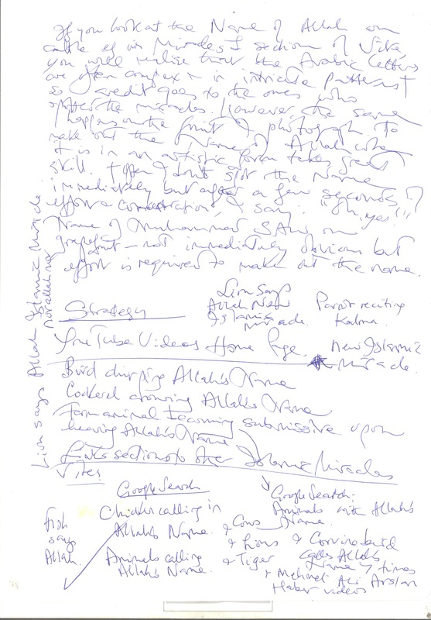
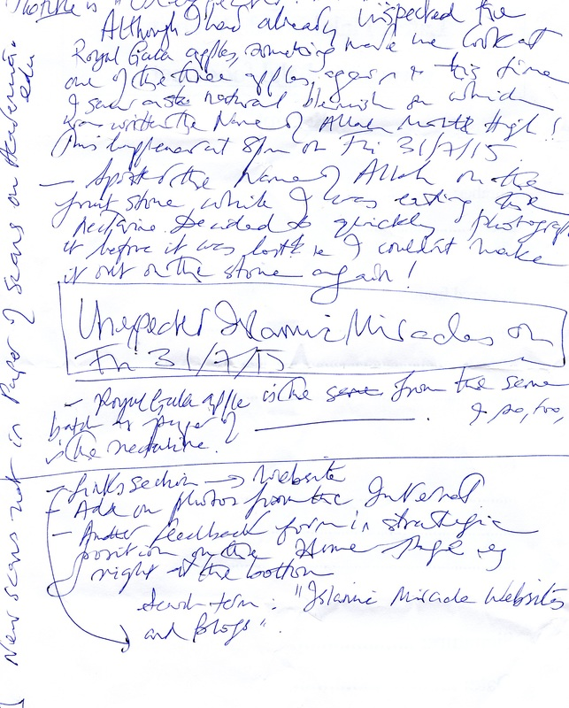
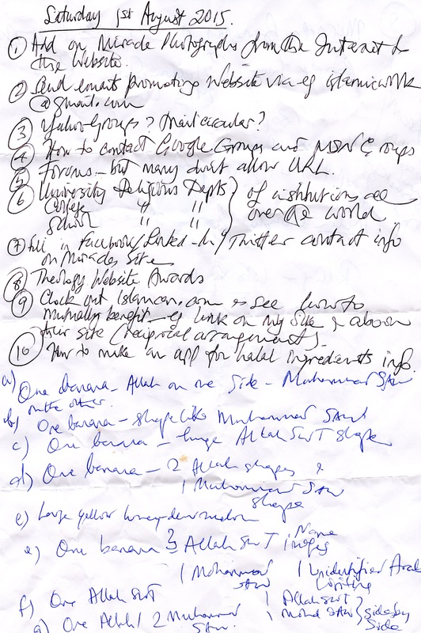
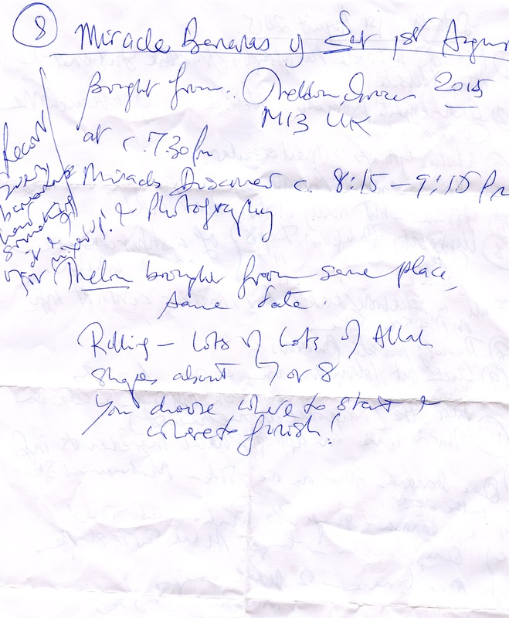
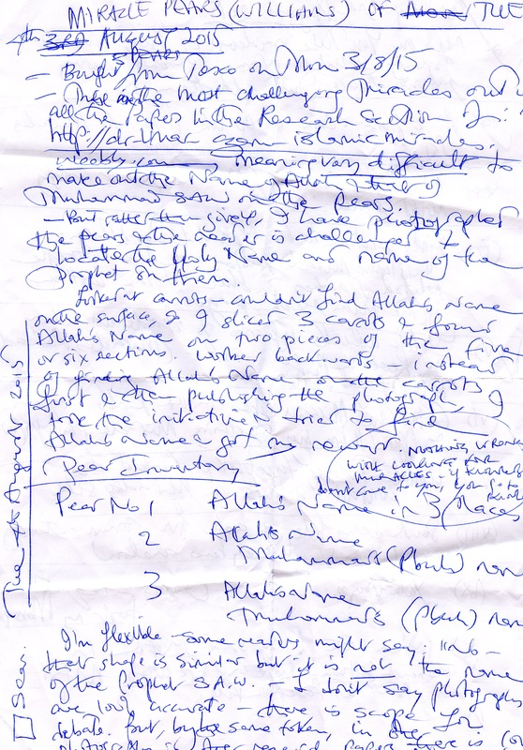
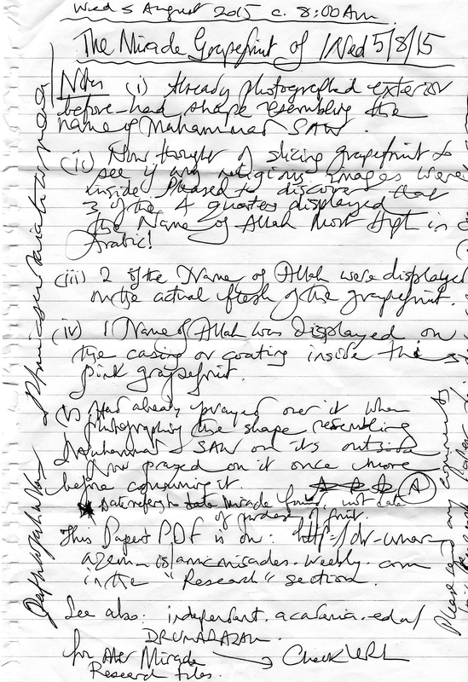

I very much hope these notes have been useful; please see my files which I trust will be very enjoyable:

http://dr-umar-azam- islamicmiracles.weebly.com/research.html

https://independent.academia.edu/DRUMARA

ZAM

https://independent.academia.edu/AZAMU

