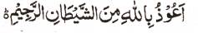

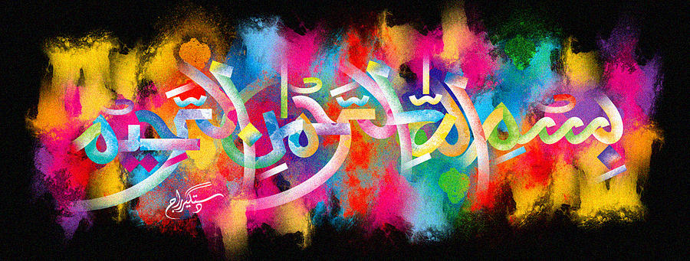
http://dr-umar-azam-islamicmiracles.weebly.com
Please see my Site, especially the RESEARCH section and sign my Guest Book with your unique comments.

Two Examples of the Name of Allah in the Inner Cross-Section of a Piece of Coconut
The Exclusive Islamic Miracle Photographs of Dr Umar Elahi Azam
^{Thursday} 31st December 2015
Manchester, UK

Introduction
The two impressions of The Name of Allah in the cross-section are fairly clear.
