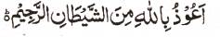

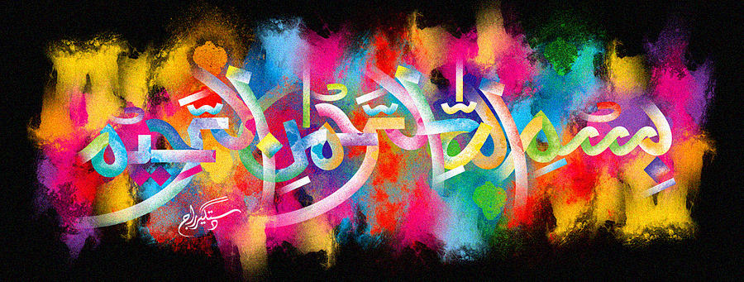
Two Impressions of The Name of Allah on the External Surface of a Red Delicious Apple
The Exclusive Islamic Miracle Photographs of Dr Umar Elahi Azam
^{Thursday 24t} December 2015
Manchester, UK

Introduction
The natural lines of this red delicious apple formed one of the impressions of the Name of Allah The other inmpression of the Holy Name had been formed around the root and its whereabouts was highlighted with the reflection of light.
