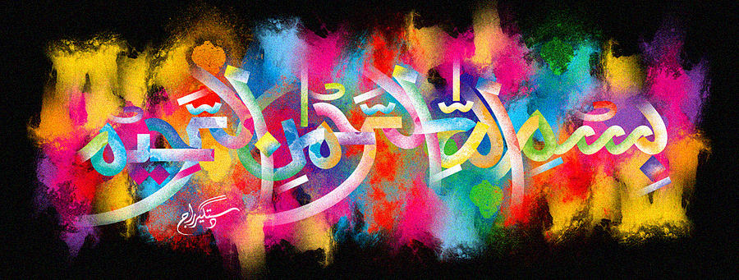
Two Further Markings of the Name of Allah 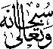 on Bananas Previously Photographed
Vol 1
The Exclusive Islamic Miracle Photographs of Dr Umar Elahi Azam
Wednesday 30th September 2015
Manchester, UK
Introduction
two further markings of the name of Allah were found on banana no 1 and many more markings of the holy name were found on bANANA NO 6. THESE WERE TWO OF THE BANanas that had been photographed earlier [see mrf nos 3003-306 on HTTP://DR-UMAR-AZAM-ISLAMICMIRACLES.WEEBLY.COM/RESEARCH.HTLM ] THE NAME OF ALLAH was on the surface of, and on the base of the stem of, banana no 1. and the holy name was on the base of the stem, in the cross-section of, and in the inner peel [multiple markings but i took photographs of 2 such markings] of banana no 6.
