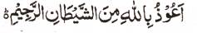

The Pith of a Pink Grapefruit Forms The Name of Allah
The Exclusive Islamic Miracle Photographs of Dr Umar Elahi Azam
^{Thursday 24th} December 2015
Manchester, UK

Introduction
This was a large grapefruit with a sharp, tangy taste. So the impression of the Holy Name was large and very clear also.
And even the reflection of light in one of the photographs seems to contain the Name of Allah
