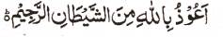

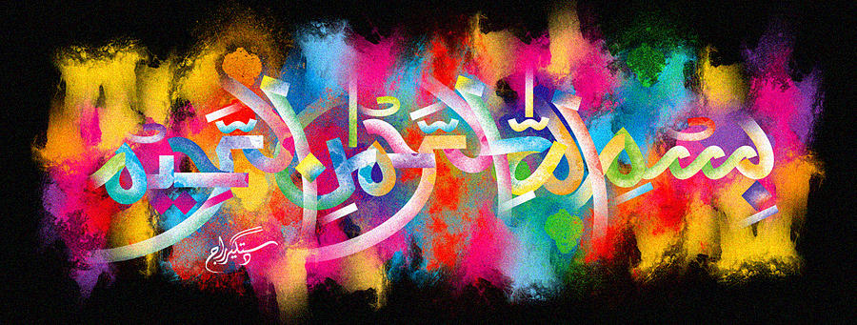
The Natural Lines on the External Surface of a Conference Pear Form The Name of Allah 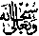 Symmetrically on Vertically Opposite Sides
The Exclusive Islamic Miracle Photographs of Dr Umar Elahi Azam
^{Thursday 24t} December 2015
Manchester, UK

Introduction
The natural lines of this pear clearly formed the Name of Allah on vertically opposite sides, so that the Holy Nme could be read in both directions.
