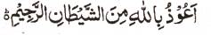

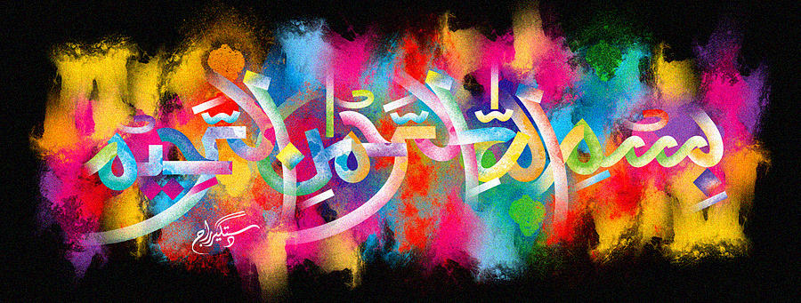
The Name of Muhammad 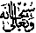 on a Giant Satsuma
The Exclusive Islamic Miracle Photographs of Dr Umar Elahi Azam
^{Thursday} 7th January 2016
Manchester, UK

Introduction
The name of the Prophet 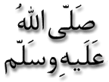was written in an artistic way on this Satsuma and the letter ‘dal’ of the end of the Prophet’s name was very emphatic.

