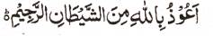

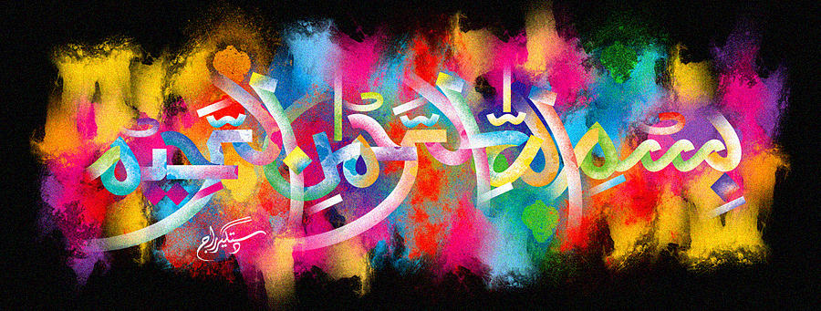
The Name of Muhammad 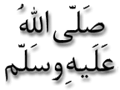 on the Second Miracle Pomegranate of 1-1-16
The Exclusive Islamic Miracle Photographs of Dr Umar Elahi Azam
^{Thursday} 7th January 2016
Manchester, UK

Introduction
This is admittedly a very artistic and complex marking. To decipher the name of the Prophet , followthe lettering from right at the top of the pomegranate to right at the bottom of the fruit where the huge ‘dal’ at the end of the Muhammad’s name is.
