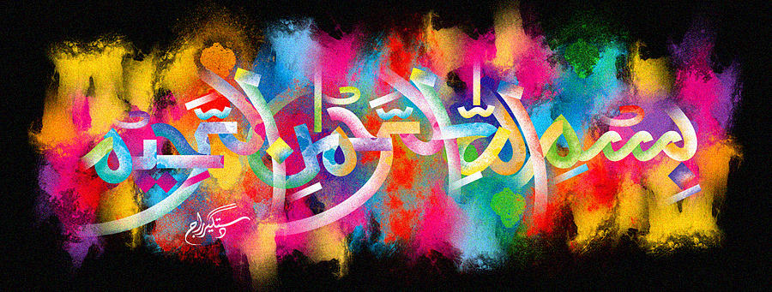
The Name of Muhammad
on the Inner Peel of a Mandarin
The Exclusive Islamic Miracle Photographs of Dr Umar Elahi Azam
Saturday 31st October 2015
Manchester, UK

Introduction
There was a clear impression of the name of Muhammad on the inner peel of a mandarin.

