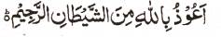

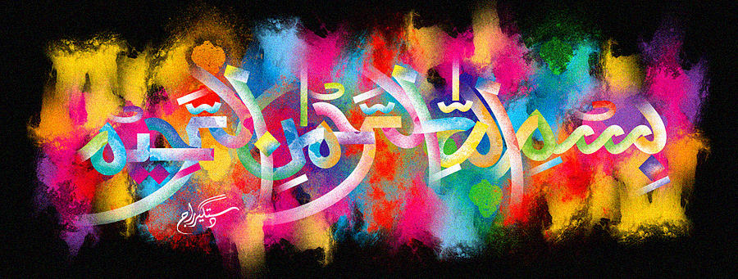
http://dr-umar-azam-islamicmiracles.weebly.com
Please see my Site, especially the RESEARCH section and sign my Guest Book with your unique comments.

THE NAME OF MUHAMMAD 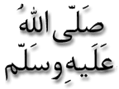 ON the CANTALOUPE MELON of 1 JANUARY 2016
The Exclusive Islamic Miracle Photographs of Dr Umar Elahi Azam
^{SATURDAY} 2 JANUARY 2016
Manchester, UK
Although these photographs belong to Dr Umar Azam, readers have permission to use any/all of the photographs as long as the source is acknowledged. Miracle Photographs, for example, have been shared on Twitter in the recent past.
Introduction
The light-green markings are the impressions that form the Name of Muhammad and the natural, artistic design is admittedly complex.
