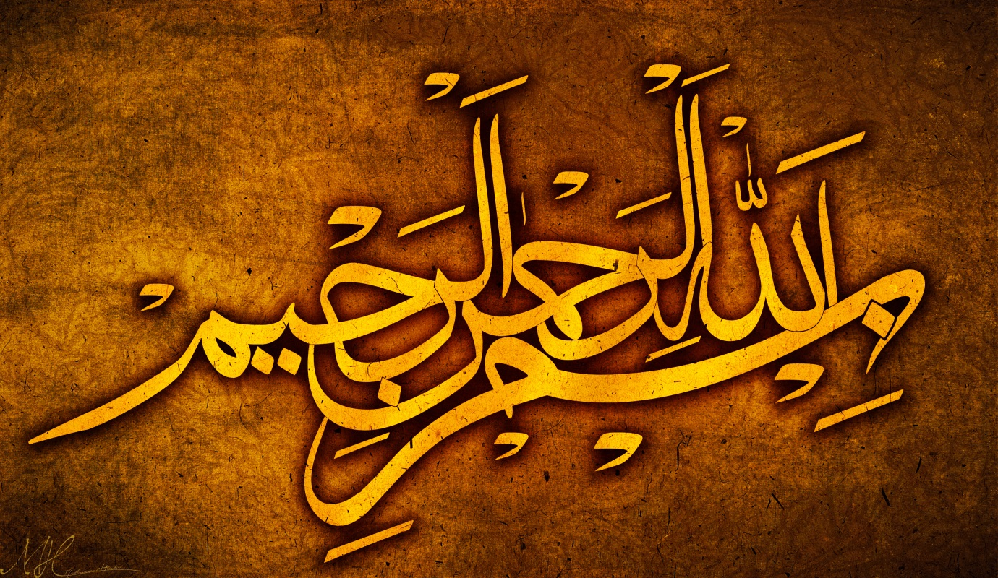
THE NAME OF MUHAMMAD 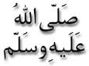INAN ARTISTIC FORM ON AN ORANGE
The Exclusive Islamic Miracle Photographs of Dr Umar Elahi Azam
Wednesday 9th September 2015
Manchester, UK

Introduction
The Name of Muhammad as an artistic marking was clearly visible on the outside surface orange.
