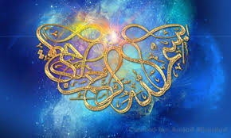

***T*he NAME OF ALLAH**http://paradise-jewels.webs.com/swt.gif

**ON 3 POMEGRANATES**

***T*he Exclusive Islamic Miracle Photographs of Dr Umar Elahi Azam**

***T*hursday 27thAugust 2015**

***M*anchester, UK**

**Introduction**

**These three pomegranates, along with other fruit, were bought from *Worldwide Store*, Wilmslow Road, Manchester UK on Wednesday 26th August 2015**

Picture Picture PicturePicture

