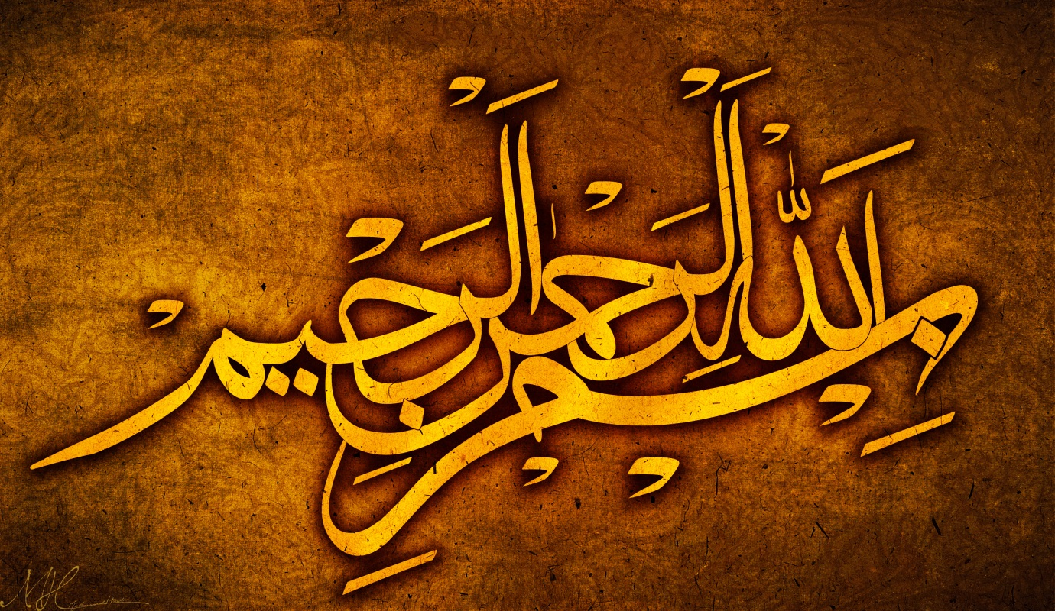
THE NAME OF ALLAH 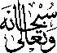 ON THE SURFACE OF AN APRICOT
The Exclusive Islamic Miracle Photographs of Dr Umar Elahi Azam
Saturday 5th September 2015
Manchester, UK

Introduction
The Name of Allah in Arabic was found to be present on the surface of an apricot from a punnet bought from Manchester Superstore, Stockport Road, Manchester UK on Friday 4 September 2015.
