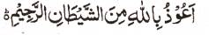

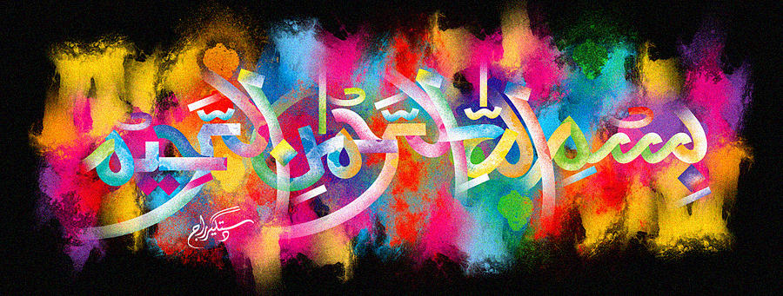
http://dr-umar-azam-islamicmiracles.weebly.com
Please see my Site, especially the RESEARCH section and sign my Guest Book with your unique comments.

The Name of Allah on the External Surface of a Persimmon
The Exclusive Islamic Miracle Photographs of Dr Umar Elahi Azam
^{Wednesday} 30th December 2015
Manchester, UK

Introduction
the Name of Allah
