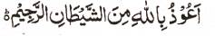

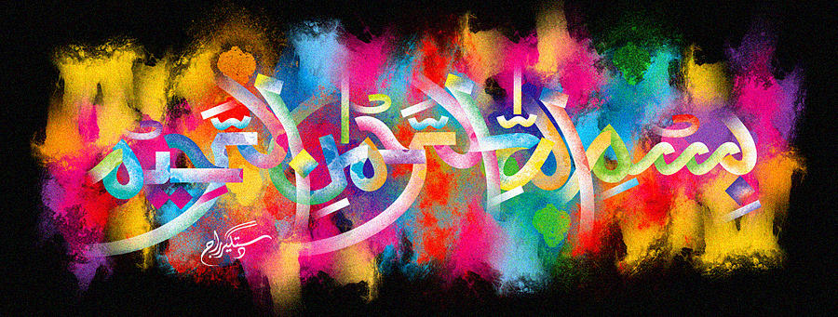
http://dr-umar-azam-islamicmiracles.weebly.com
Please see my Site, especially the RESEARCH section and sign my Guest Book with your unique comments.

Multiple Impressions of The Name of Allah on Pieces of Halal Fried Chicken – Vol 2
The Exclusive Islamic Miracle Photographs of Dr Umar Elahi Azam
Thursday 14 January 2016
Manchester, UK
Although these photographs belong to Dr Umar Azam, readers have permission to use any/all of the photographs as long as the source is acknowledged. Miracle Photographs, for example, have been shared on Twitter in the recent past.

Introduction
I bought a meal of halal fried chicken, fries and drinks from Chicken Cottage, Wilmslow Road, Manchester UK and, during my meal, I noticed prominent impressions of The Name of Allah in the cross-sections of different pieces of my fried chicken breast and I photographed the miraculous and natural phenomenon.
