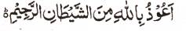

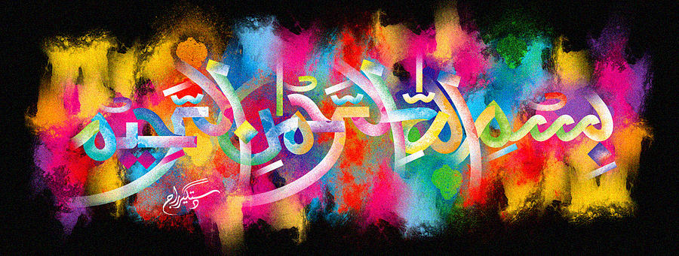
The Name of Allah 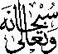 on Both Sides of a Mandarin Leaf
The Exclusive Islamic Miracle Photographs of Dr Umar Elahi Azam
^{Thursday} 17th December 2015
Manchester, UK

Introduction
The Name of Allah was found on both sides of this mandarin [tangerine] leaf.I had been busy photographing Allah’s Name on the mandarins themselves and had not thought about looking for the Holy Name on the leaves at all. But I picked one up inadvertently and a “bell rang in my mind”, so I realised that I should look for Allah’s Name on the leaf too. Hence, the idea of photographing the leaf was rather a miracle in itself! Alhamdulillah!
