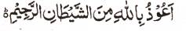

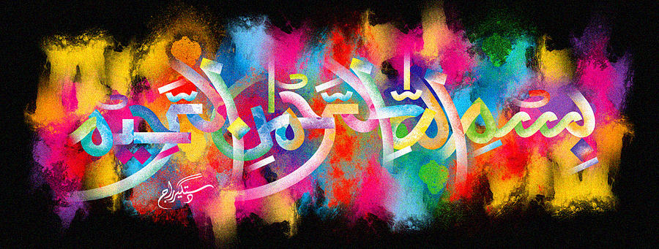
http://dr-umar-azam-islamicmiracles.weebly.com
Please see my Site, especially the RESEARCH section and sign my Guest Book with your unique comments.

The Name of Allah on an Exotic Vegetable
The Exclusive Islamic Miracle Photographs of Dr Umar Elahi Azam
Monday 4 January 2016
Manchester, UK
Although these photographs belong to Dr Umar Azam, readers have permission to use any/all of the photographs as long as the source is acknowledged. Miracle Photographs, for example, have been shared on Twitter in the recent past.

Introduction
The Name of Allah was impressed in the long lines on the exterior surface of this exotic vegetable from the Indian subcontinent , a vegetable related to the tinda; see: https://en.wikipedia.org/wiki/Tinda These photographs were taken in the Appna Continental Superstore, Mitre Road, Manchester UK.
