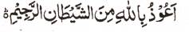

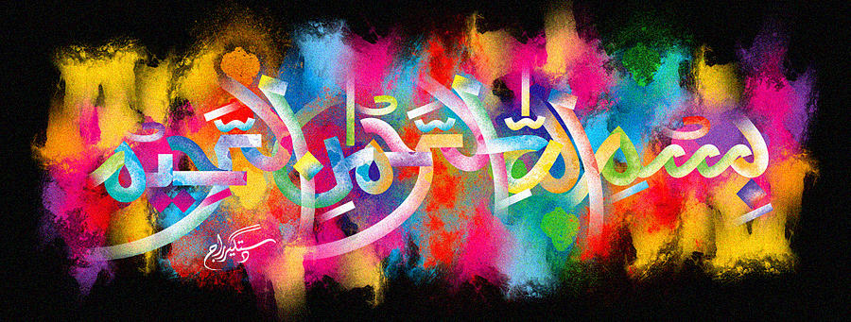
http://dr-umar-azam-islamicmiracles.weebly.com
Please see my Site, especially the RESEARCH section and sign my Guest Book with your unique comments.

THE NAME OF ALLAH A STRAWBERRY LEAF
The Exclusive Islamic Miracle Photographs of Dr Umar Elahi Azam
^{FRIDAY} 1ST JANUARY 2016
Manchester, UK

Introduction
This impression was not at all easy to photograph and I had to discard a number of inefficient photographs.
