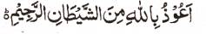

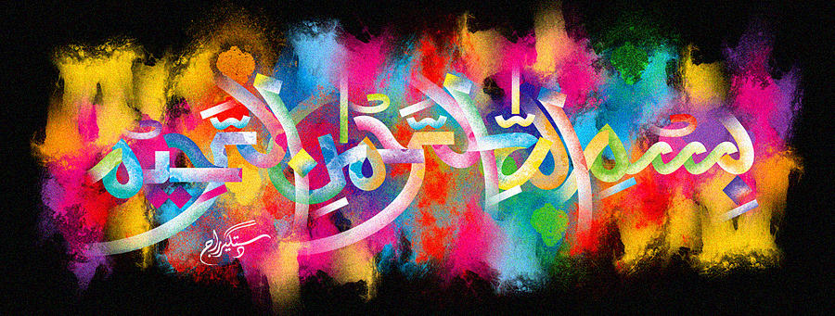
http://dr-umar-azam-islamicmiracles.weebly.com
Please see my Site, especially the RESEARCH section and sign my Guest Book with your unique comments.

The Name of Allah on Leaf of Spinach
The Exclusive Islamic Miracle Photographs of Dr Umar Elahi Azam
Wednesday 13 January 2016
Manchester, UK
Although these photographs belong to Dr Umar Azam, readers have permission to use any/all of the photographs as long as the source is acknowledged. Miracle Photographs, for example, have been shared on Twitter in the recent past.

Introduction
The Name of Allah is at the centre, on the right-hand side, of the spinach leaf in the photographs below.
