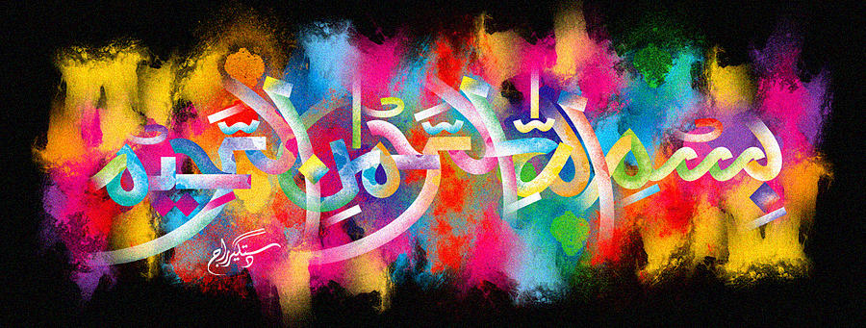
The Name of Allah SWT in the Pattern of my Blanket
The Exclusive Islamic Miracle Photographs of Dr Umar Elahi Azam
Saturday 31st October 2015
Manchester, UK

Introduction
To make out The Name of Allah 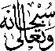 from the pattern of my Italian, mink blanket, look at the dark-brown shade of lettering (not the orange one) and it is also evident that the letters ‘Alif’(oat the far right) and ‘Ha’(at the far left) are detached from the rest of the Holy Name. MashAllah, this is just one of many Islamic miracle co-incidences that have been happening to me over the last few months or so. In this case, the artistic marking of the Name of Allah SWT was formed, from all the possible designs, patterns and colours available in this type of ultra-warm blanket!
