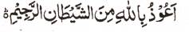

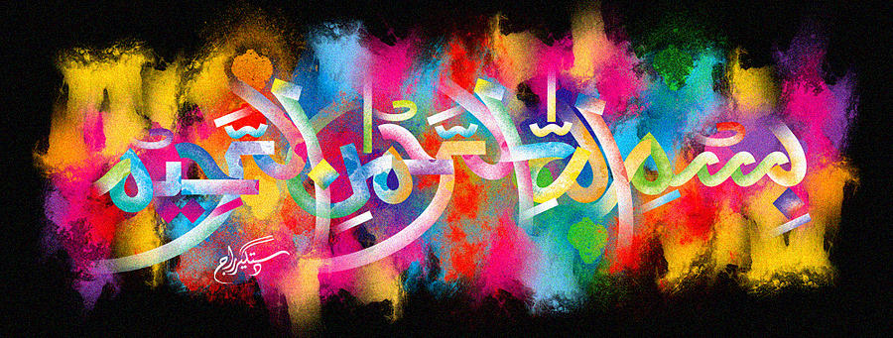
http://dr-umar-azam-islamicmiracles.weebly.com
Please see my Site, especially the RESEARCH section and sign my Guest Book with your unique comments.

The Name of Allah Formed on an Empty Bottle of Milk
The Exclusive Islamic Miracle Photographs of Dr Umar Elahi Azam
Tuesday 5th January 2016
Manchester, UK
Although these photographs belong to Dr Umar Azam, readers have permission to use any/all of the photographs as long as the source is acknowledged. Miracle Photographs, for example, have been shared on Twitter in the recent past.

Introduction
