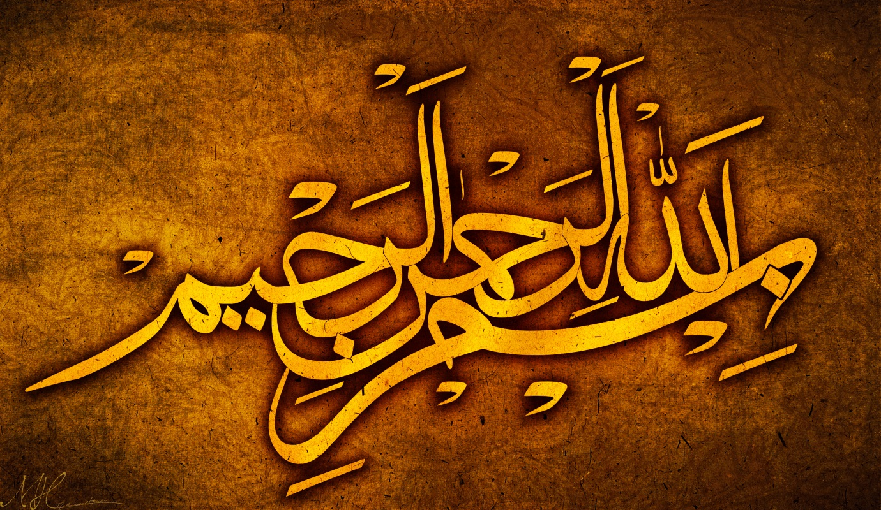
THE NAME OF ALLAH 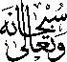 ON YET ANOTHER BANANAS
The Exclusive Islamic Miracle Photographs of Dr Umar Elahi Azam
Sunday 6th September 2015
Manchester, UK

Introduction
This banana is a different one from all those photographed so far.
