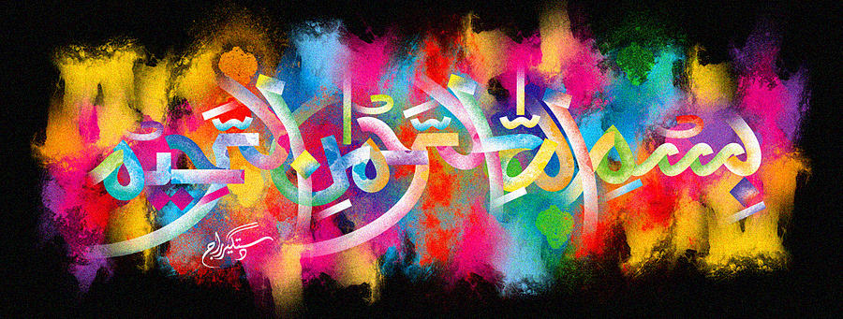
The Name of Allah 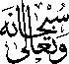 on the Ripe Part of a Banana Fruit
The Exclusive Islamic Miracle Photographs of Dr Umar Elahi Azam
Wednesday 7th October 2015
Manchester, UK
Introduction
The Name of Allah was discovered on a ripe part while I was actually eating the fruit.l
