http://www.quran-st.net/ELEMENTS%20OF%20NAMAZ_files/image008.jpg



***The Name of Allah***  ***and that of Muhammad 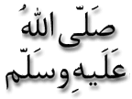 on the Outer Nut of a Coconut***

***T*he Exclusive Islamic Miracle Photographs of Dr Umar Elahi Azam**

**Monday 28th December 2015**

***M*anchester, UK**

**Introduction**

**This was the miracle coconut of 26th December 2015**

Picture Picture PicturePicture

