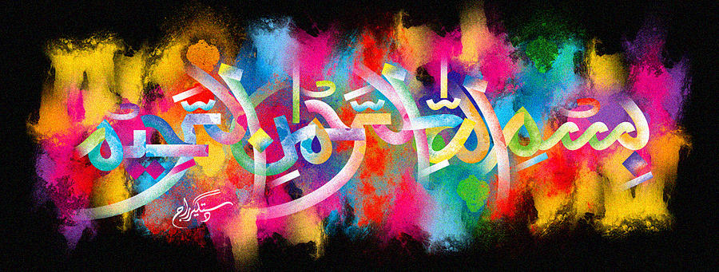
The Name of Allah 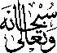 on the Inner Peel of a Turkish Black Bursa Fig
The Exclusive Islamic Miracle Photographs of Dr Umar Elahi Azam
Friday 23rd October 2015
Manchester, UK

Introduction
A large impression of The Name of Allah was formed on the inner peel of the Turkish, black Bursa fig.
