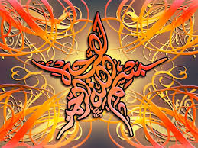
The Name of Allah 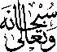 on the Miracle Banana of 14th September 2015
The Exclusive Islamic Miracle Photographs of Dr Umar Elahi Azam
Monday 14th September 2015
Manchester, UK
Introduction
The Name of Allah , was discovered on the outer surface of a banana.
