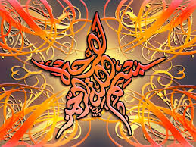

***T*he Name of Allah  in the Cross-Sections and on the Seeds of 2 Yellow Plums**

**Vol. 2**

***T*he Exclusive Islamic Miracle Photographs of Dr Umar Elahi Azam**

***M*onday 14th September 2015**

***M*anchester, UK**

**Introduction**

**The Name of Allah , was discovered in the cross-sections and seeds of two yellow Spanish, *Sungold* variety of plums.**

PicturePicturePicturePicture

