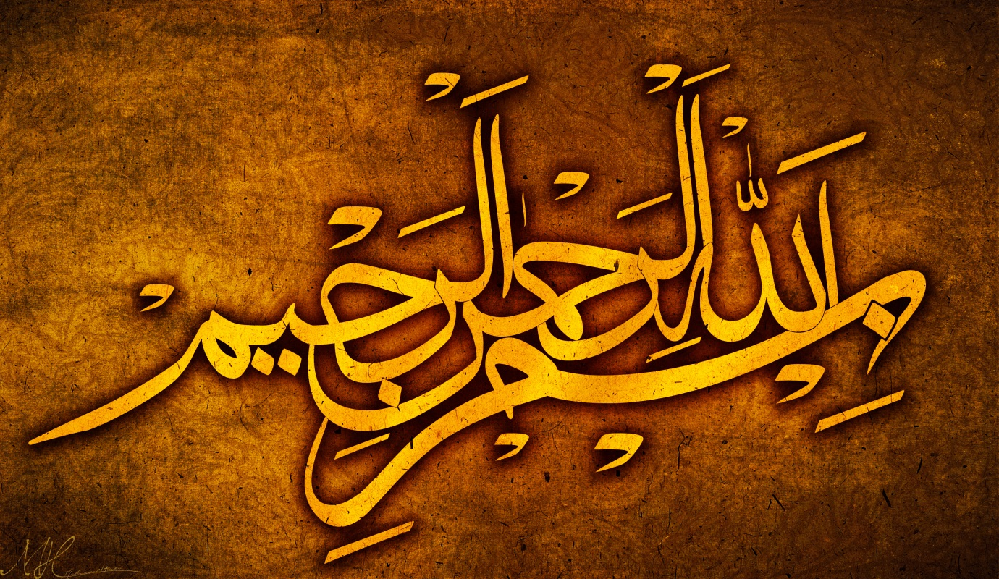
THE NAME OF ALLAH 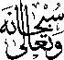 ON 2 BANANAS
The Exclusive Islamic Miracle Photographs of Dr Umar Elahi Azam
Sunday 6th September 2015
Manchester, UK

Introduction
I bought a seekh kebab [3 grilled lamb seekh kebabs on a naan bread] from the Camel One take-away on Wilmslow Road’s ‘Curry Mile’ at c. midnight [after finishing my MRF Files work for the night] and, at home, I noticed that the Name of Allah was present on my naan bread!
