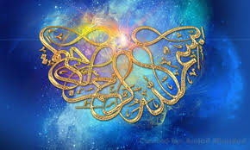
The NAME OF ALLAH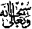
ON A SAMOSA AND FORMED BY CHILLI SAUCE AND YOGHURT SAUCE
The Exclusive Islamic Miracle Photographs of Dr Umar Elahi Azam
Friday 28th August 2015
Manchester, UK

Introduction
Iwent to Camel One take away on Wilmslow Road Manchester UK for some light refreshment [before the intensive work of making my Miracles Photographs Research Files] between C. 8:00 – 8:30 pm on Friday 28th August. I ordered three meat samosas with salad and sauces and a can of Coca Cola, to dine in. I noticed the Name of Allah first on one samosa, so I photographed the Praised Name. Then, a few minutes later, I again noticed something – that, this time, some of my chilli and yoghurt sauce mixture on my plate had formed the Name of Allah Most High so, omce again, I got busy with the camera lens of my Sony Xperia M2 Smartphone.
