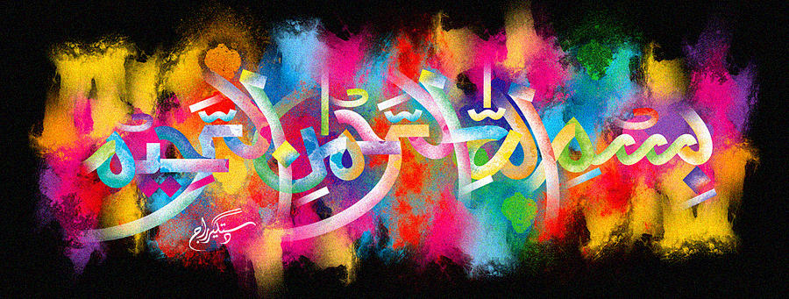
The Name of Allah 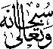 Made on My Left Palm
The Exclusive Islamic Miracle Photographs of Dr Umar Elahi Azam
Monday 19thOctober 2015
Manchester, UK

Introduction
The Name of Allah was naturally made by lines on the Mount of Venus on the palm of my left hand. I think the Holy Name can be read both ways [up and down] and the letter ‘Ha’ at the end of Allah’s Name is very well developed.
