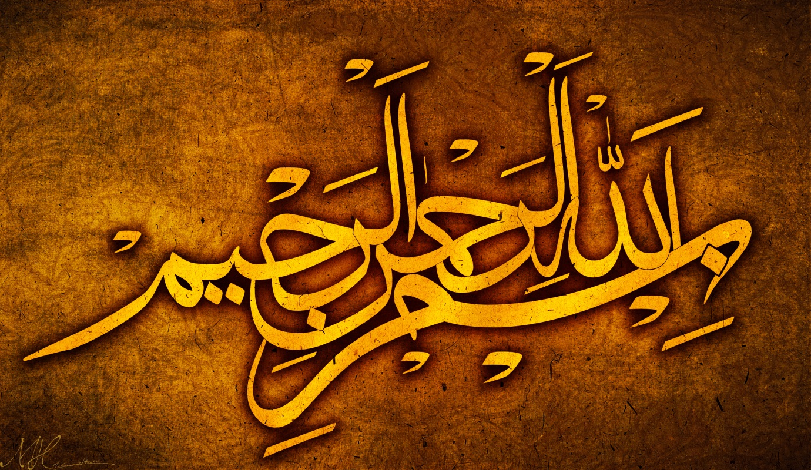
THE NAME OF ALLAH 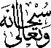ON 5 DIFFERENT DRIED APRICOTS
VOL 2
The Exclusive Islamic Miracle Photographs of Dr Umar Elahi Azam
Frisday 4th September 2015
Manchester, UK

Introduction
Natural markings of The Name of Allah in Arabic were formed on five different dried apricots. MashAllah, the Holy Name was so prolific on my dried fruit that it could have been 15 or 20 apricots – but that would have meant just repeating the work, although it would have been interesting to see the various designs of the Name of Allah on many more dried apricots!
