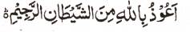

The Name of Allah 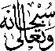 on a Withered Mandarin Leaf
The Exclusive Islamic Miracle Photographs of Dr Umar Elahi Azam
^{Wednesday} 16th December 2015
Manchester, UK

Introduction
The Name of Allah was found on the withered leaf of a mandarin fruit and it was typical of the holy markings on other leaves of other mandarins too.
