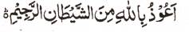

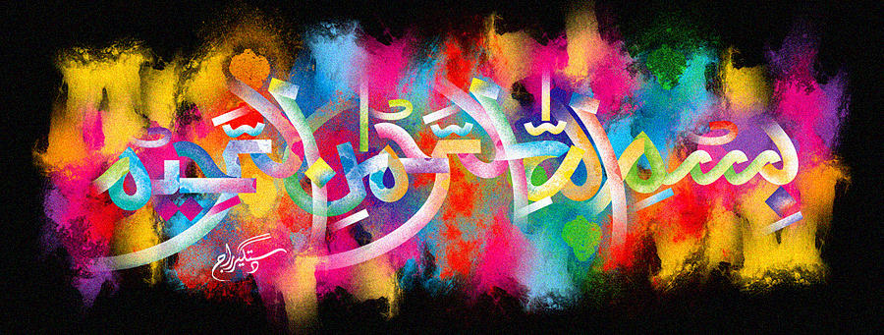
The Name of Allah 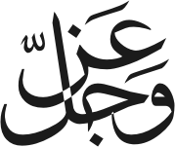 on a Miniature Aubergine
The Exclusive Islamic Miracle Photographs of Dr Umar Elahi Azam
^{Saturday} 9th January 2016
Manchester, UK

Introduction
The Holy Name is made by the natural lines on the green part of the vegetable. These photographs were taken at Appna Continental Cash and Carry, Mitre Road, Manchester M13 UK.

The Name of Allah on a Miniature Aubergine
The Exclusive Islamic Miracle Photographs of Dr Umar Elahi Azam
^{Saturday} 9th January 2016
Manchester, UK

Introduction
The Holy Name is made by the natural lines on the green part of the vegetable. These photographs were taken at Appna Continental Cash and Carry, Mitre Road, Manchester M13 UK.
