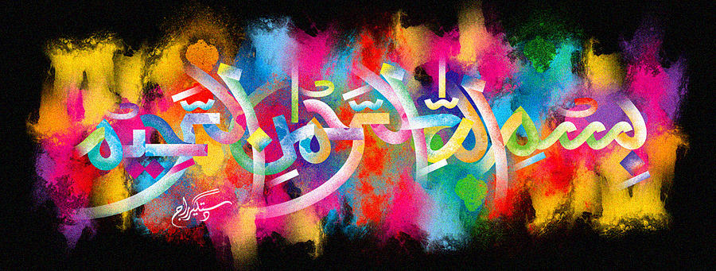
The Name of Allah 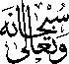 on the Slice of a Mandarin
The Exclusive Islamic Miracle Photographs of Dr Umar Elahi Azam
Saturday 31st October 2015
Manchester, UK

Introduction
The Name of Allah was formed on a mandarin and there were multiple formations of the Holy Name on all other slices too; this is just a sample.
