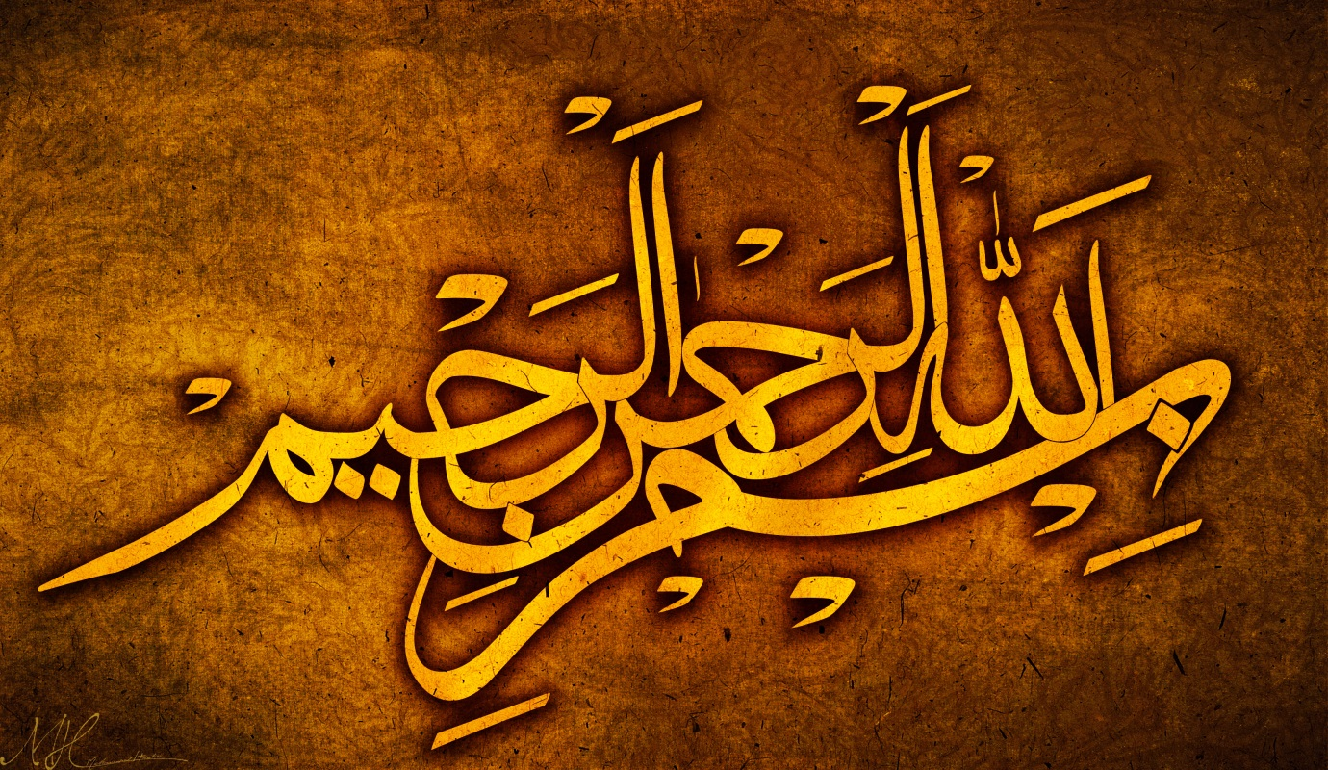
THE NAME OF ALLAH 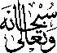 ON 2 BANANAS
Vol 1
The Exclusive Islamic Miracle Photographs of Dr Umar Elahi Azam
Sunday 6th September 2015
Manchester, UK

Introduction

The Name of Allah in Arabic was found to be present on the outside surface two bananas. I accidentally broke a banana off from its bunch whilst trying to place the bunch with other fruit. I wondered if the banana was special in any way. Then I found the complex marking of the Name of Allah on it. I have drawn parallel lines in ink to show the outline of the marking.

* This beautiful formatting happened accidentally –it just displayed automatically- whilst I was trying to copy and paste the !!

