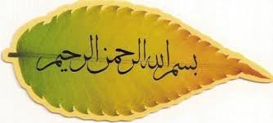
The NAME OF ALLAH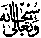
IN THE CROSS-SECTION OF AN APRICOT
The Exclusive Islamic Miracle Photographs of Dr Umar Elahi Azam
Tuesday 1st August 2015
Manchester, UK

Introduction
The Name of Allah was found made in the cross-section of apricots packaged in a punnet, bought from Manchester Superstores on Stockport Road, Manchester UK on Monday 31 August.
.
