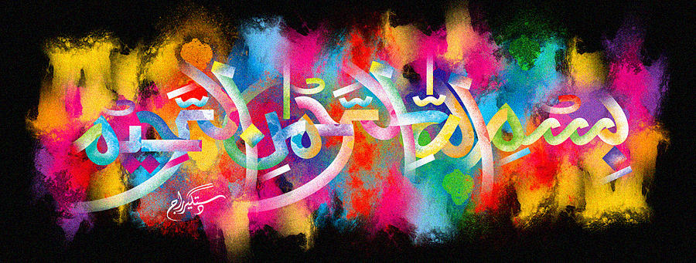
The Name of Allah in the Interior of the Second Miracle Jaffa Orange of 11/11/15 Vol 2
The Exclusive Islamic Miracle Photographs of Dr Umar Elahi Azam
Wednesday 11th November 2015
Manchester, UK

Introduction
There were 4 markings of The Name of Allah in the interior of this orange, 3 made by the pith and one by the cross-section.
