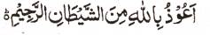

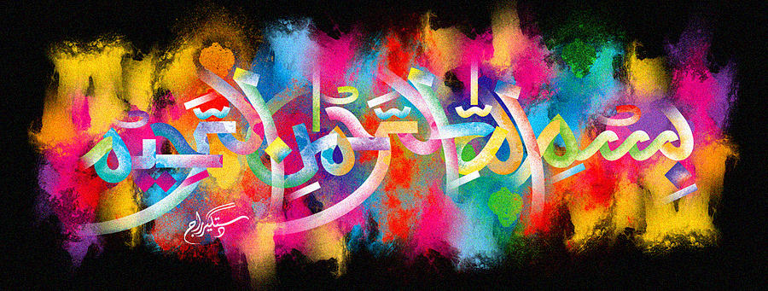
The Name of Allah in the Interior of a Pink Grapefruit
The Exclusive Islamic Miracle Photographs of Dr Umar Elahi Azam
^{Wednesday} 23rd December 2015
Manchester, UK

Introduction
This pink grapefruit was bought from Food Basket, a new superstore, on Withington Road, Whalley Range, Manchester UK on Monday 21st December.
