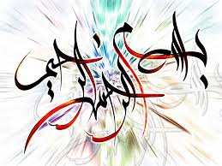 THE NAME OF ALLAH 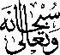FORMED BY THE INNER PEEL OF A SATSUMA
The Exclusive Islamic Miracle Photographs of Dr Umar Elahi Azam
Frisday 4th September 2015
Manchester, UK

Introduction
The Name of Allah was formed by the inner peel of a Satsuma. A few minutes earlier, I had seen another marking of the Name of Allah but, unfortunately, I damaged that one whilst trying to separate it from the rest of the inner peel. These satsumas were bought, amongst other fruit and vegetables, from Manchester Superstores, Stockport Road, Manchester UK on Monday 31st August. This was the same satsuma as in MRF No. 165 in the Research section of: http://dr-umar-azam-islamicmiracles.weebly.com
