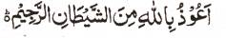

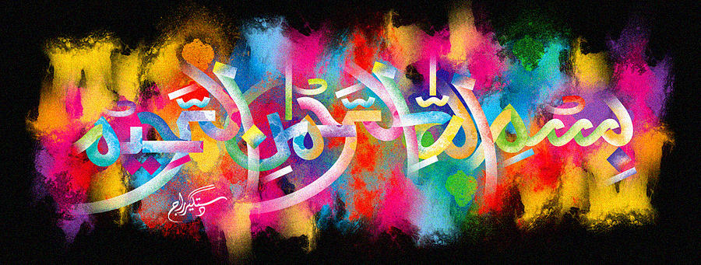
http://dr-umar-azam-islamicmiracles.weebly.com
Please see my Site, especially the RESEARCH section and sign my Guest Book with your unique comments.

The Name of Allah in the Cross-Section of a Boiled Egg
The Exclusive Islamic Miracle Photographs of Dr Umar Elahi Azam
^{Tuesday} 29th December 2015
Manchester, UK

Introduction
There were impressions of The Name of Allah on the external surface, in the cross-section and on the root of a carrot.
