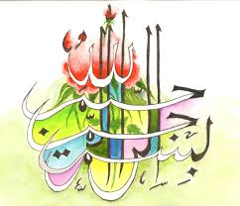
The Name of Allah 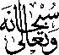 in Multiple Places on Multiple Onions
Vol 2
The Exclusive Islamic Miracle Photographs of Dr Umar Elahi Azam
Wednesday 23rd September 2015
Manchester, UK
Introduction
The Name of Allah was revolving on some onions; meaning rotating, one begins where another finishes. And the Holy Name was also in fixed places. There were too many markings to photograph without making the same point – the Miracle of the Name of Allah on onions – repeatedly.
