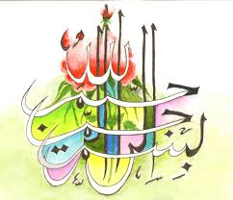
The Name of Allah 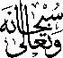 in 4 Places Inside 2 Nectarines
Vol 1
The Exclusive Islamic Miracle Photographs of Dr Umar Elahi Azam
Wednesday 23rd September 2015
Manchester, UK
Introduction
The Name of Allah was found in three places on and in the nectarines :
on the exterior, on the seed [stone] and in the interior [cross section].
