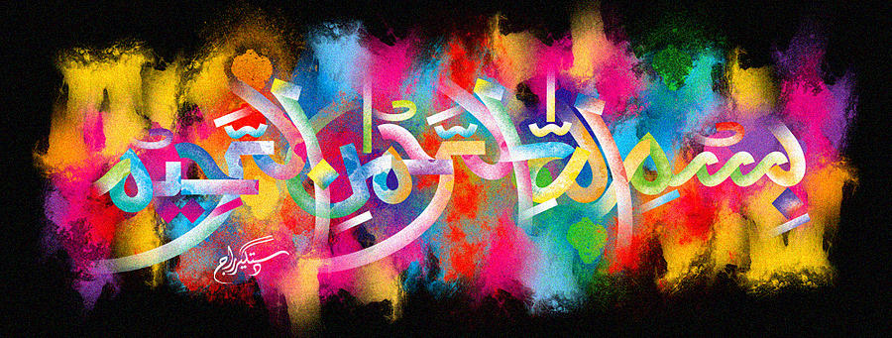
The Miracle Typhoo Tea Bag of Wednesday 21st October 2015 – Vol 2
The Exclusive Islamic Miracle Photographs of Dr Umar Elahi Azam
Wednesday 21st October 2015
Manchester, UK

Introduction
There were 3 markings of The Name of Allah 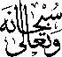 and one marking of the name of Muhammad 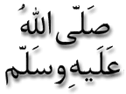 on this Typhoo tea bag.
