The Miracle Tesco Cheese Bread
The Exclusive Islamic Miracle Photographs of Dr Umar Elahi Azam
^{Saturday} 19th December 2015
Manchester, UK

Introduction
This was the first time I ever bought it – cheese bread. I t was whole-baked, like a bloomer or cob and with a subtle cheese filling all the way inside it. I found 3 impressions of The Name of Allah but these are all specimen – more impressions could have been found with the expenditure of considerably more time and effort.
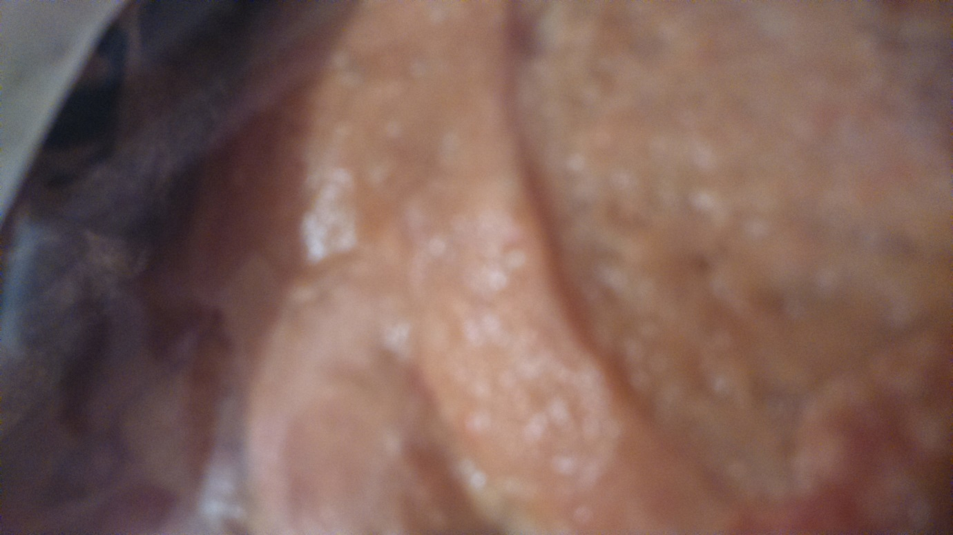

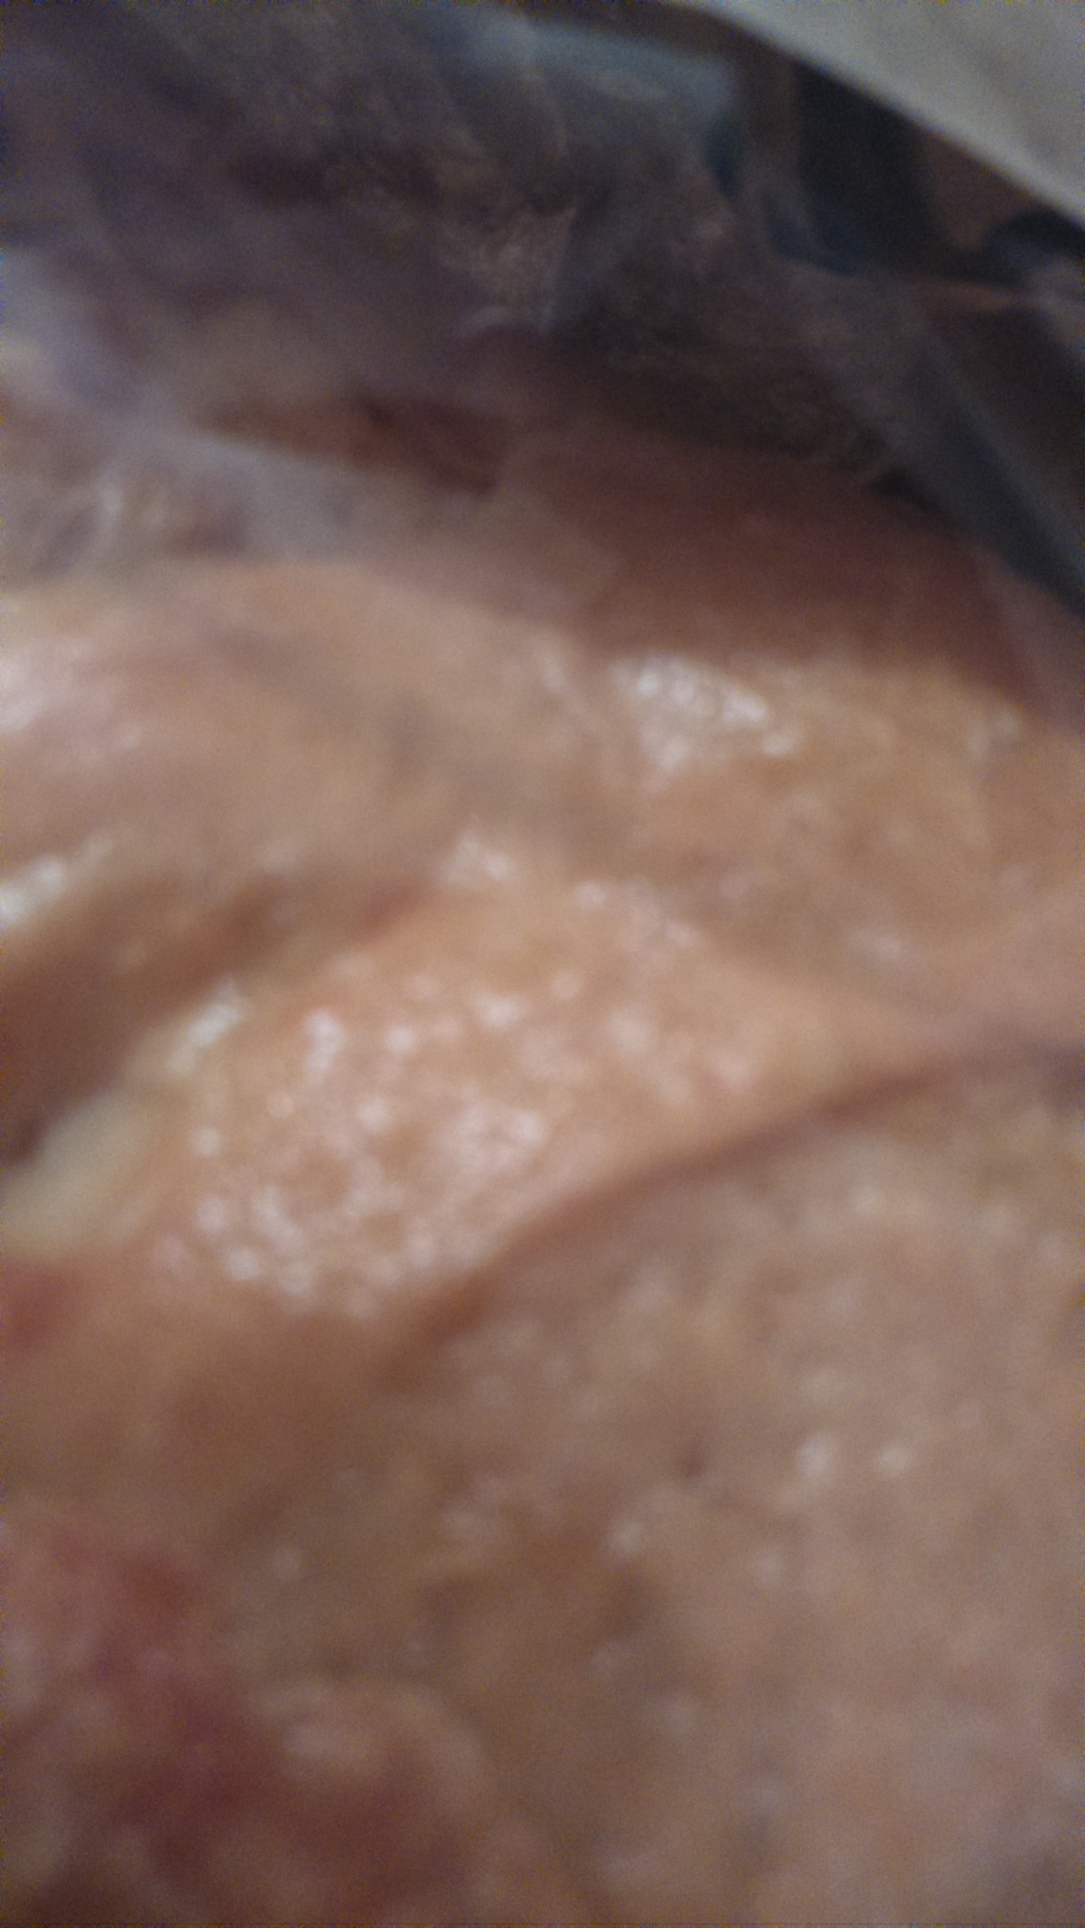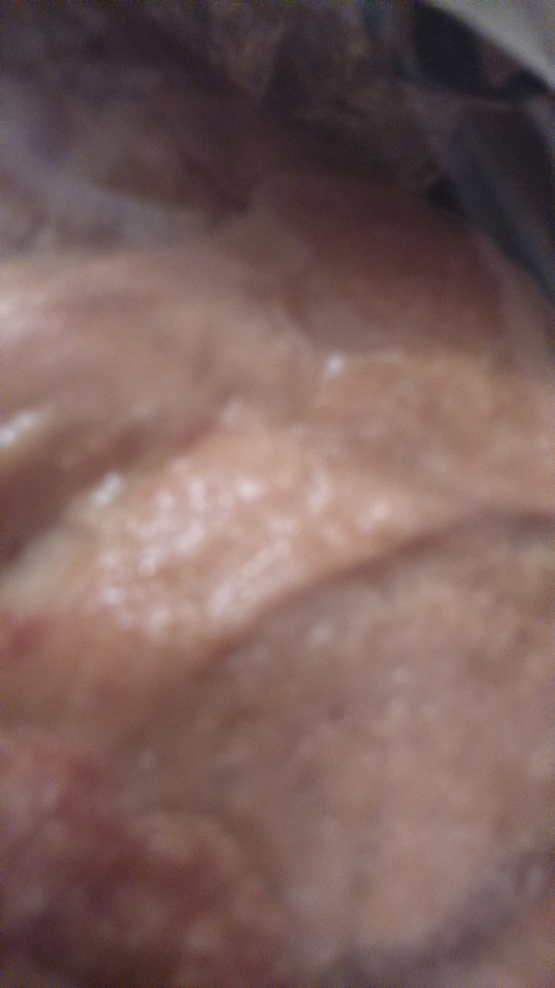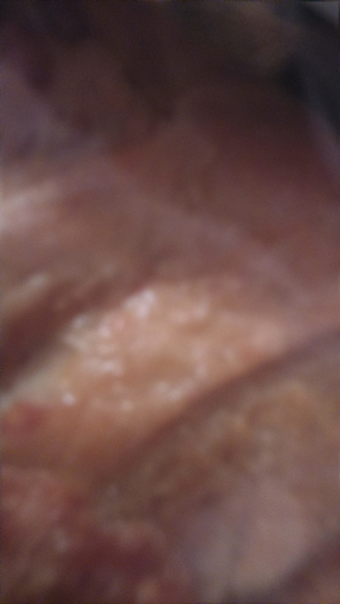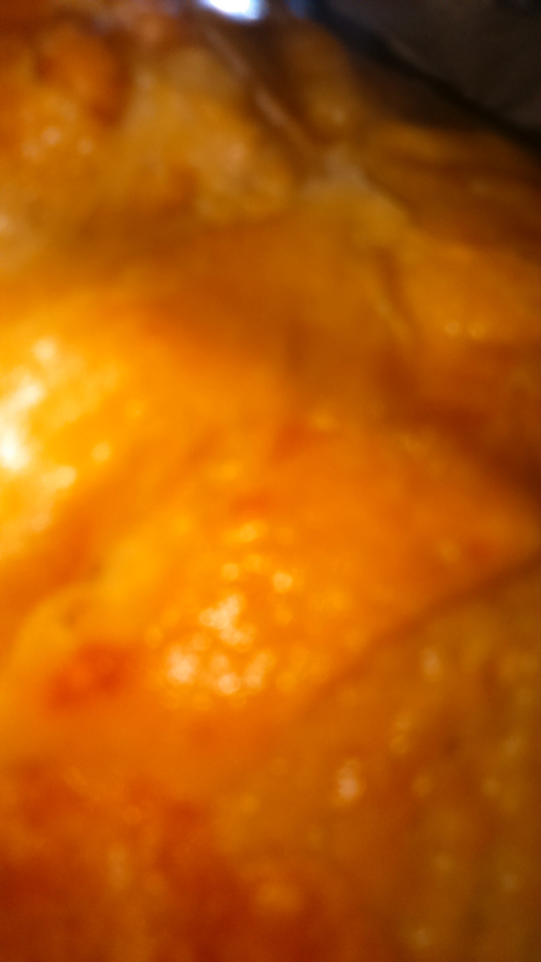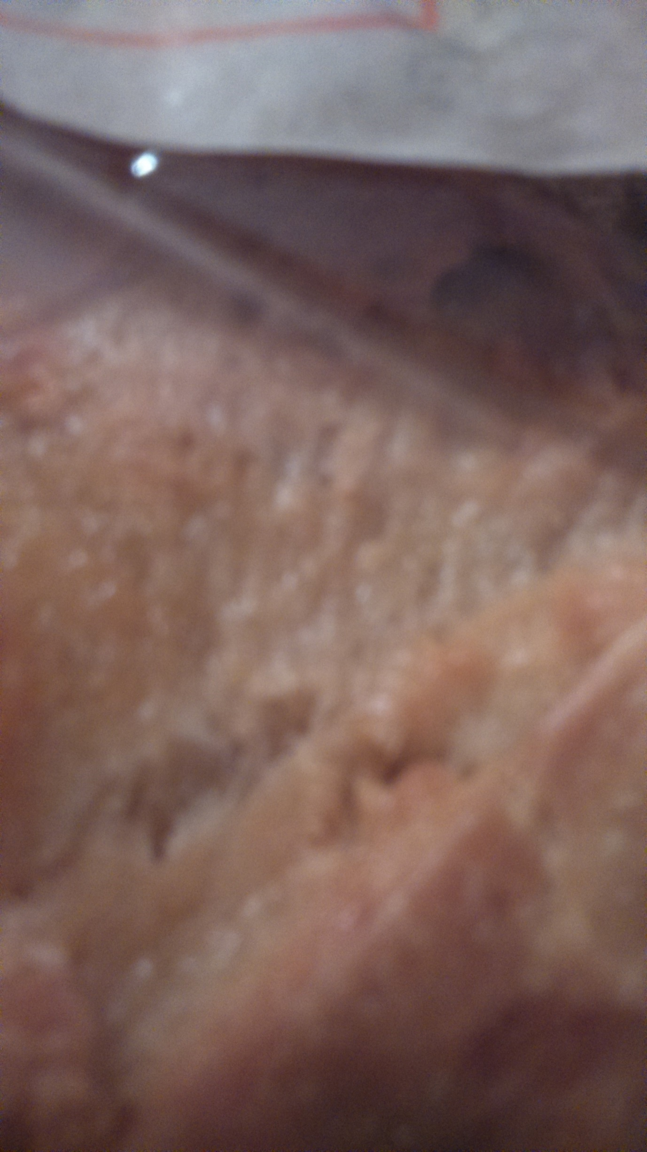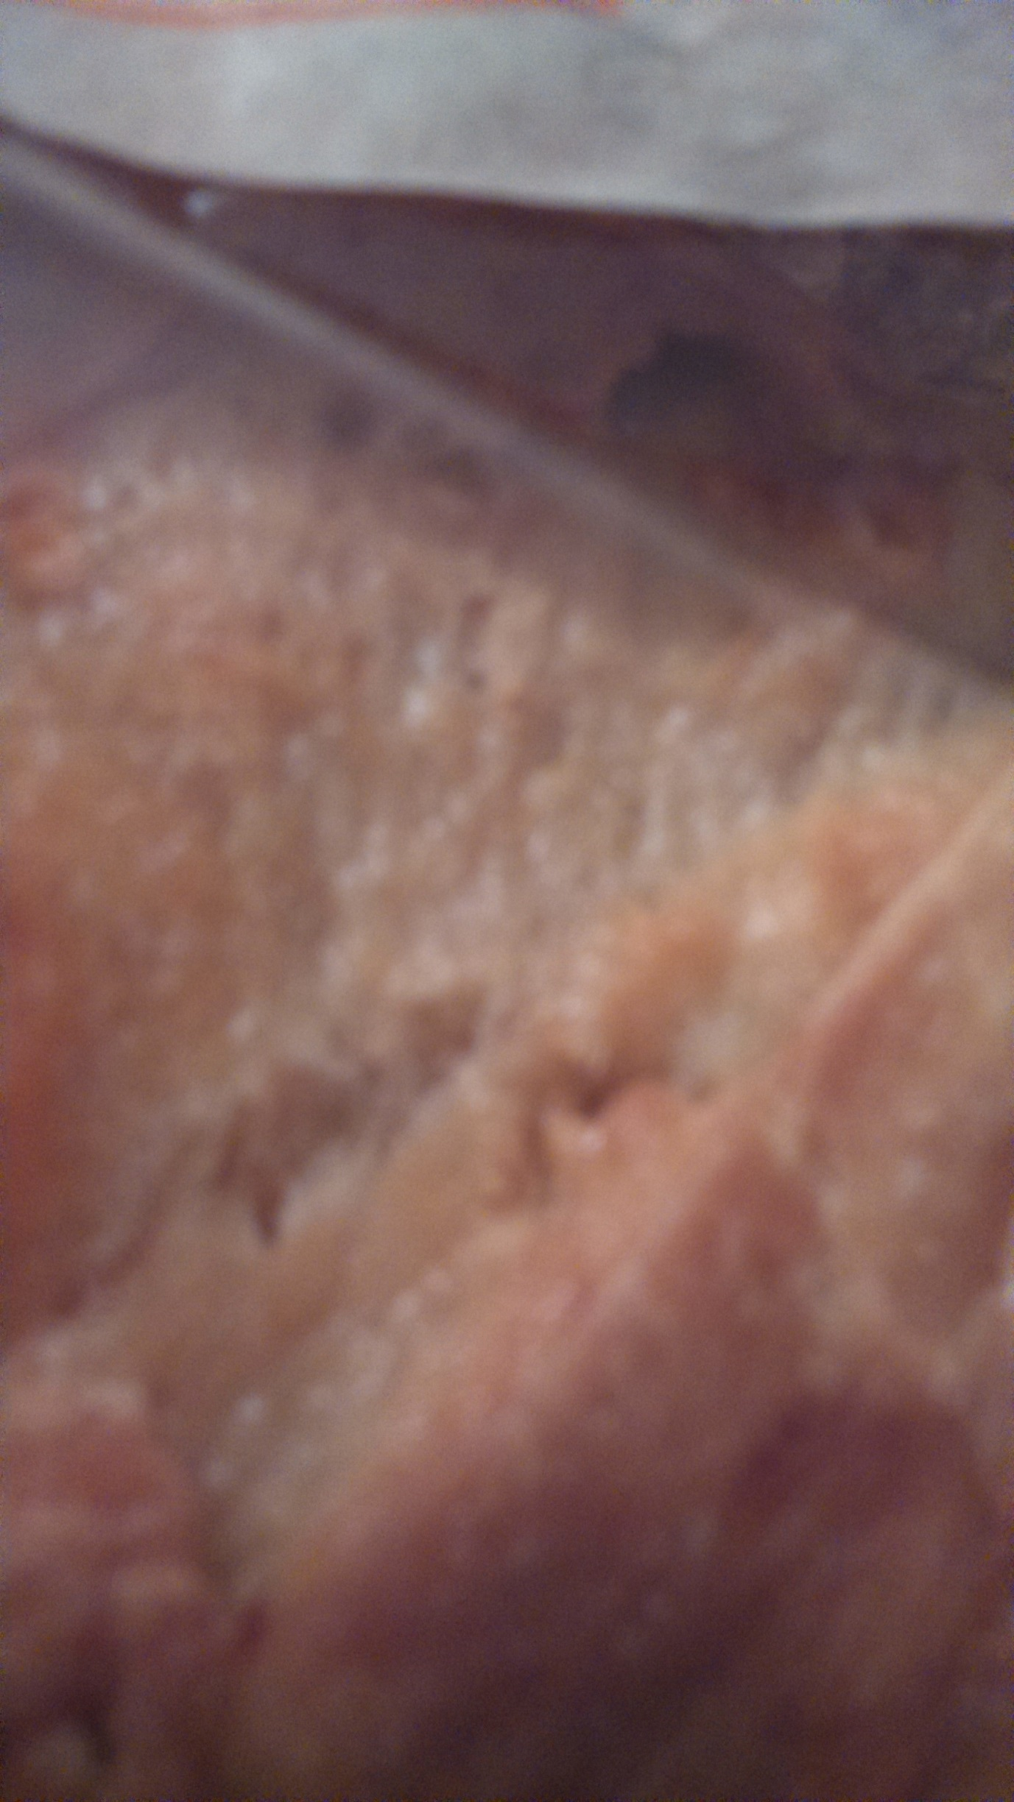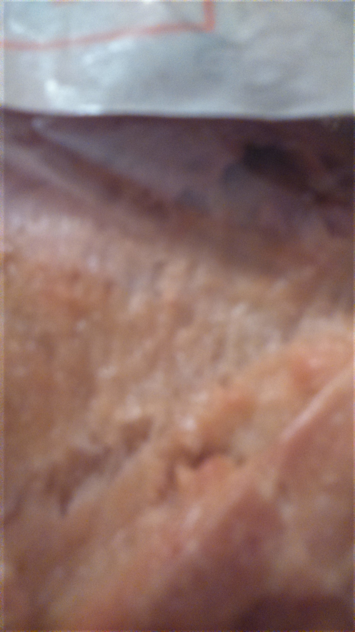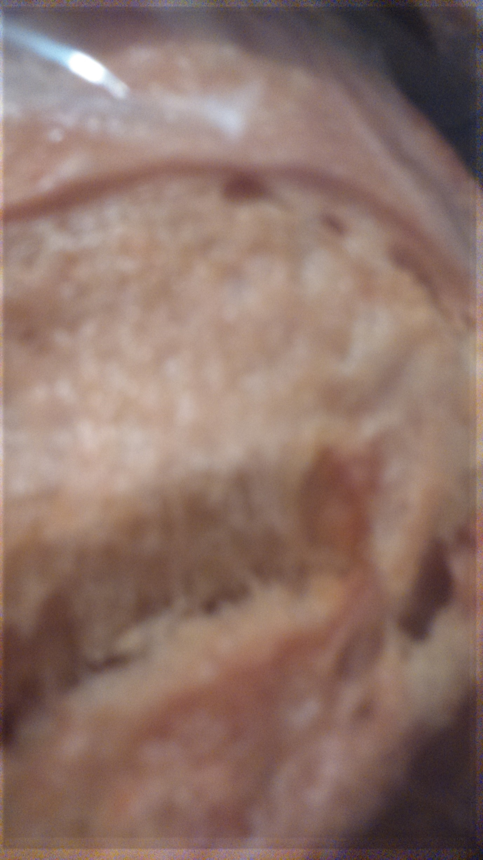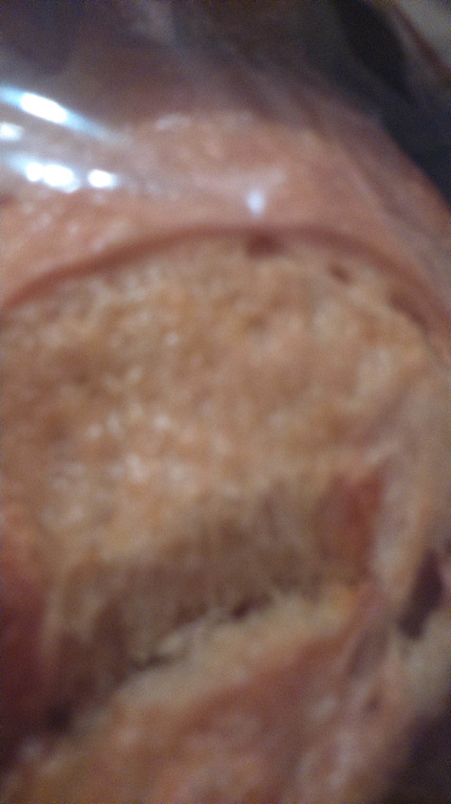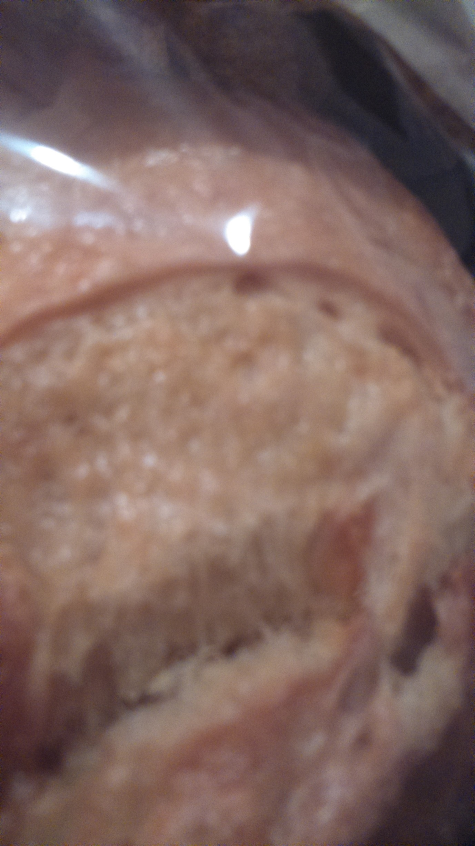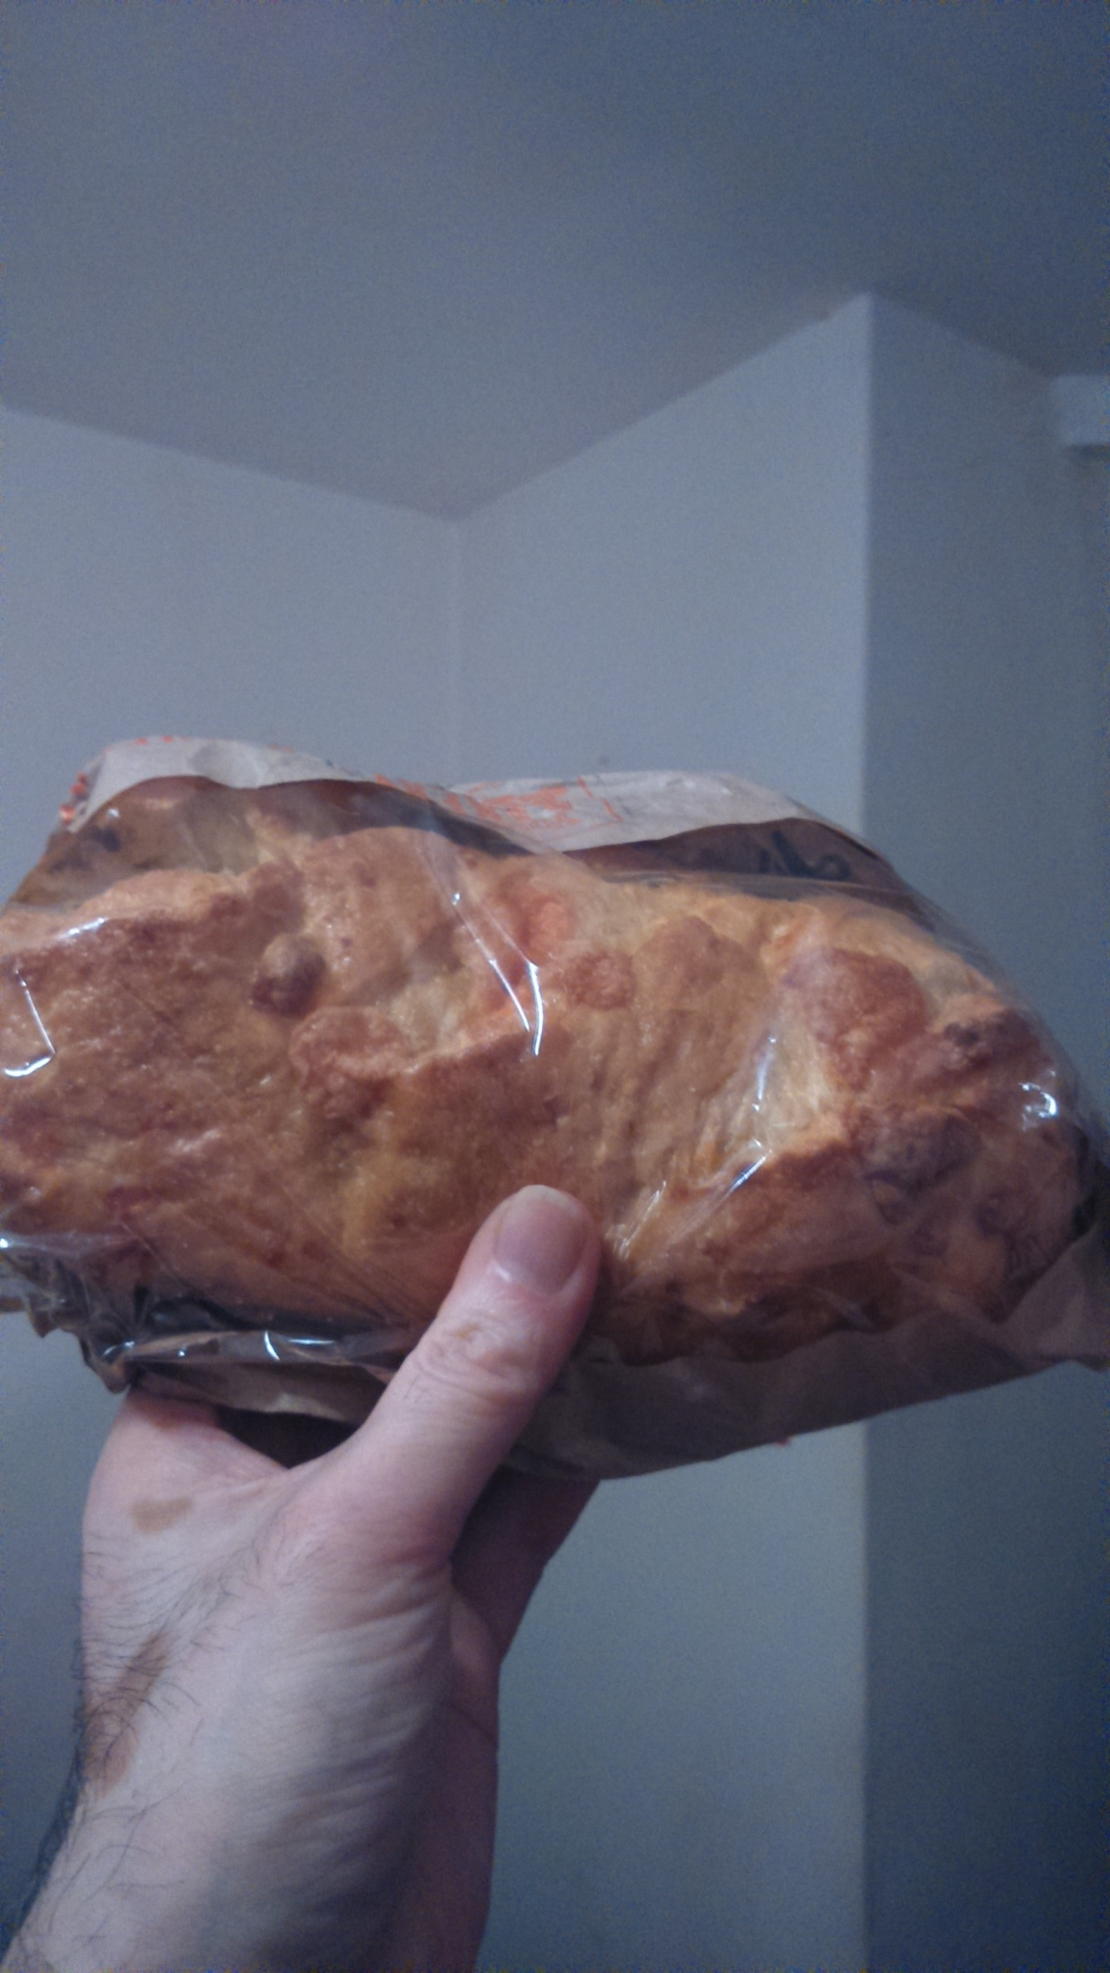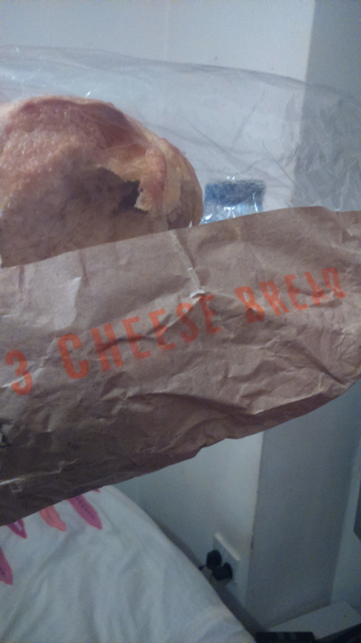

How To Make Pull-Apart Cheese Bread
COOKING LESSONS FROM THE KITCHN
PRINT RECIPE Jump to the recipe
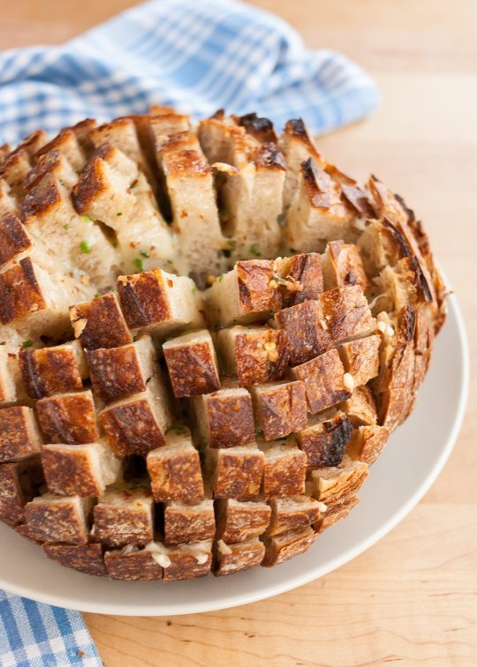
Pin it

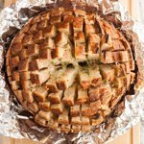

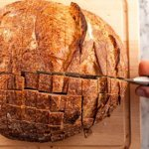

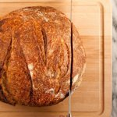

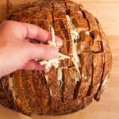

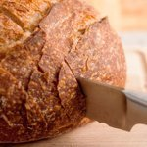

OPEN SLIDESHOW
This right here — this cheese-stuffed loaf — this is how you guarantee that any party you throw will be a smashing success. Cheese and bread are already a first-rate combination, of course, but this particular delivery method is just brilliant. I dare anyone standing in the vicinity to resist pulling off cheesy bite after cheesy bite. Dinner can burn and the power can go out, and everyone will still be perfectly content.
Want to know how this party insurance can be yours? Of course you do. Here's how to make gooey, pull-apart cheese bread, one step at a time.
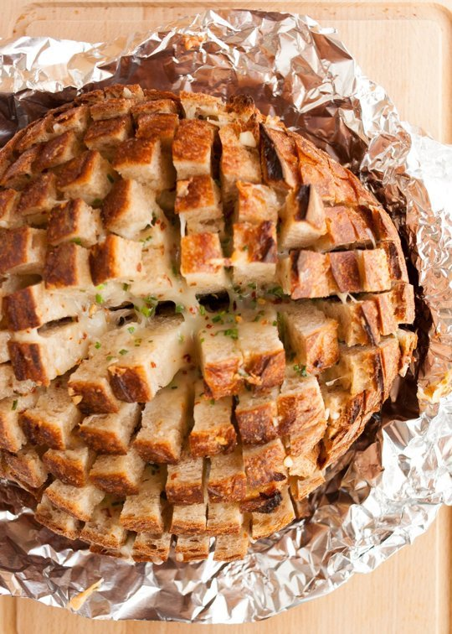
Pin it
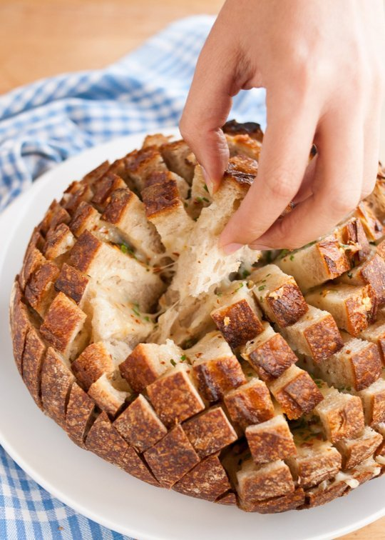
Pin it

Choosing the Loaf
Pick up an artisan loaf for this one, something with a nicely crunchy crust and some holes in the crumb. It should weigh between 12 and 16 ounces or so — this is just to give you an idea of size; the recipe is flexible enough that the exact size and weight of the loaf isn't a major factor. Round loaves are impressive to carry out to the table, but longer football-shaped bâtards or even flatter loaves of ciabatta would be fine.
When you cut the loaf, make sure not to cut all the way through so that the individual pieces of bread are still attached at the bottom. Slice the loaf in one direction first, then turn it 90-degrees and slice the other way. It can get tricky to hold the bread together when you make the second set of cuts; just do the best you can, and if any pieces fall out, just pop them back into place like puzzle pieces. There's enough cheese that none will be the wiser.
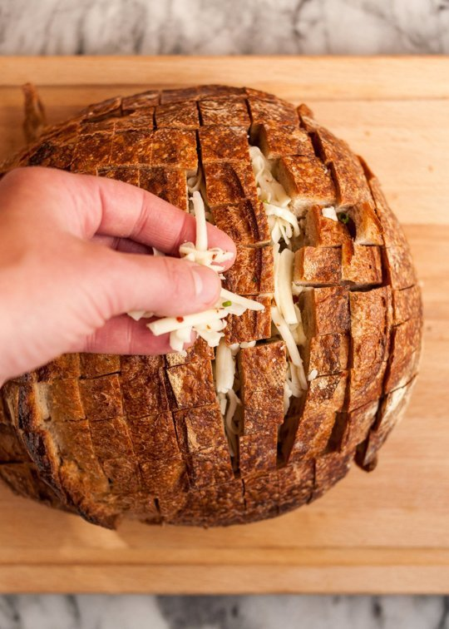
Pin it

Choosing the Cheese & Mix-Ins
You can use any favorite cheese or combination of cheeses here. Just make sure at least one of them is a gooey melting cheese, like mozzarella or swiss. I like throwing in some brie or crumbles of blue cheese, too!
Cheese and bread can do just fine on their own, of course. But playing around with the add-ins make things extra-fun. Minced chives and a few pinches of red pepper flakes are a good start. For a more substantial dish, add in some cooked bacon or sausage.

Appetizer or Side Dish?
I started off thinking of pull-apart bread as a hearty appetizer, something fun and impressive to take to tailgating party or big potluck dinner. But it also makes a great side dish with soup or chili. I love the communal aspect — everyone reaching to the middle of the table for another piece of bread between bites of soup.
Do you make pull-apart breads like this? What are some of your favorite cheese and stuffing combinations?
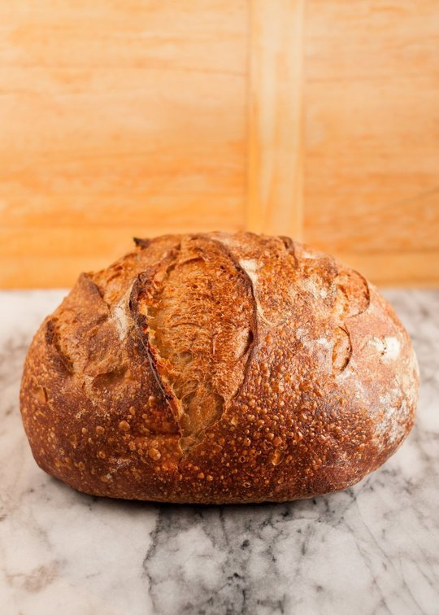
Previous image Next image
Preheat the oven to 350°F while you prep the loaf.
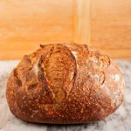
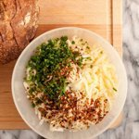
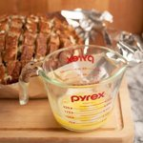

How To Make Pull-Apart Cheese Bread
Serves 6 to 8

What You Need
Ingredients
1 round loaf artisan bread (16- to 20-ounce loaf)
1 1/2 to 2 cups (6 to 8 ounces) shredded cheese, like Monterey Jack, mozzarella, provolone, cheddar, or a mix
Optional mix-ins: cooked bacon or sausage, minced chives or sliced green onions, red pepper flakes, chili powder
1/4 cup unsalted butter
Equipment
Bread knife
Cutting board
Mixing bowls
Aluminum foil

Instructions
- Preheat the oven to 350°F.
- Slice the bread into cubes: Slice the bread horizontally and vertically into 1-inch cubes. Do not slice all the way through the loaf — leave bottom of the loaf intact with the bread pieces still attached.
- Combine the cheese with any mix-ins: Toss the cheese and mix-ins together in a small bowl. This helps make sure the ingredients are evenly distributed when you stuff the bread.
- Stuff the cheese into the bread: Gently stuff the cheese into the bread between the slices. Stuff between the vertical slices first, then go back and fill in the spaces between the horizontal cuts — it's a bit easier this way! It also helps to have a helper who can hold the slices apart while you stuff.
- Pour melted butter over top: Transfer the stuffed loaf to a sheet of foil. Melt the butter in the microwave, then pour evenly over the loaf.
- Wrap the loaf tightly in foil.
- Bake the loaf: Bake the loaf for 20 minutes. Uncover the top and bake for another 10 minutes, until the cheese is totally melted and the top of the loaf is crispy.
- Serve immediately: Serve the loaf while still hot from the oven.

Recipe Notes
- Make-Ahead Moment: The bread can be stuffed a few hours ahead of when you plan to serve. It will be fine on the counter for an hour, or you can refrigerate it (wrapped in foil) for a few hours. Wait to pour the butter over the top until just before you put it in the oven.
- The leftover edges make a great midnight snack — sprinkle with a little extra cheese and run it under the broiler until bubbly.
This recipe has been updated. Originally published February 2012.
