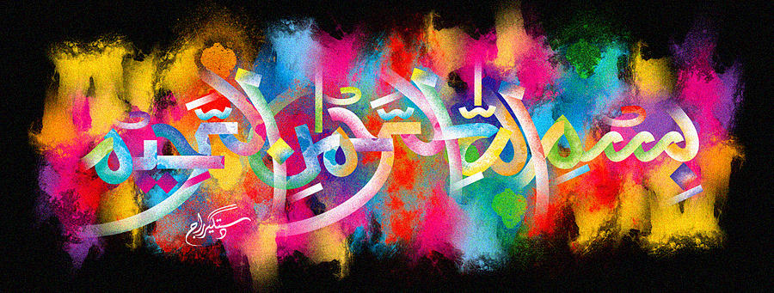
The Miracle Tangerines of Friday 25th September 2015
Vol 1
The Exclusive Islamic Miracle Photographs of Dr Umar Elahi Azam
Sunday 27th September 2015
Manchester, UK
Introduction
On two tangerines, there was the marking of The Name of Allah 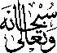 on the exterior surface of one tangerine and on most slices of both tangerines!
