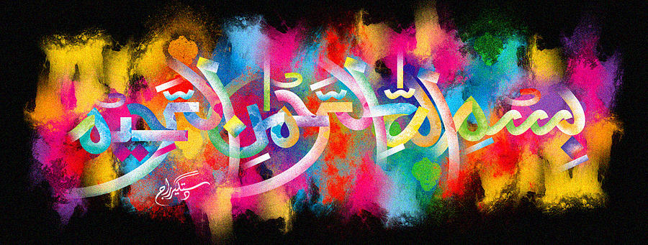
The Miracle South Arican Mandarin of Friday 2nd October 2015
Vol 2
The Exclusive Islamic Miracle Photographs of Dr Umar Elahi Azam
Friday 2nd October 2015
Manchester, UK
Introduction
There were 2 impressions ofThe name of Allah 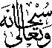 on the exterior surface of the mandarin. Because of all the tiny dots camouflaging the Holy Name, the method I used for deciphering was to reflect the light of the bulb 9onto the surface of the mandarin and then let the rays illuminate the location of the Holy Name.

